<https://www.youtube.com/watch?v=jxuNLH5dXCs&list=PLblh5JKOoLUICTaGLRoHQDuF_7q2GfuJF&index=52>

Today we're gonna do part 3 in our series on gradient boost.

This time we'll focus on the main ideas of how gradient boost can be used for classification.

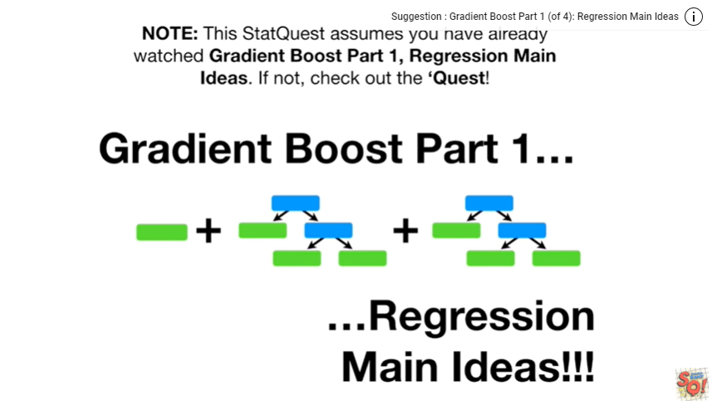

Note : this stat quest assumes you have already watched gradient boost part 1, regression main ideas, if not check out the quest.

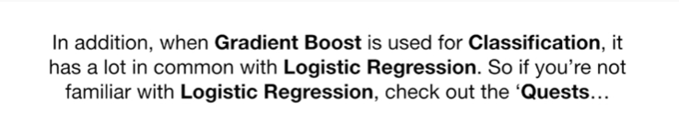

In addition when gradient boost is used for classification it has a lot in common of logistic regression.

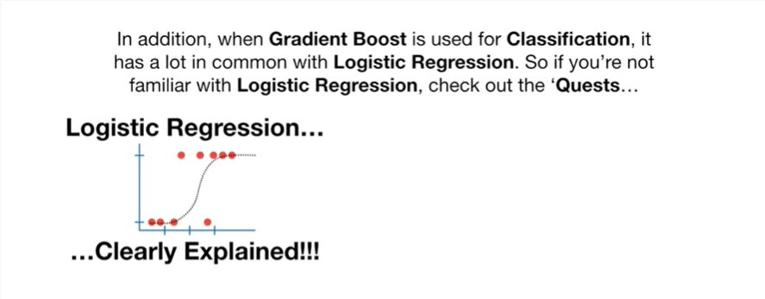

So if you're not already familiar with logistic regression,

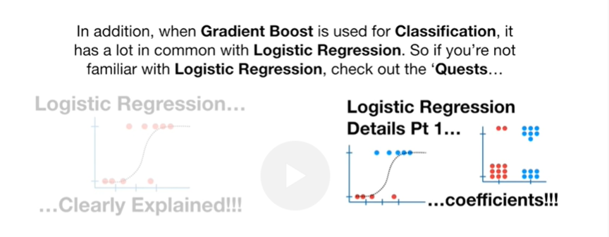

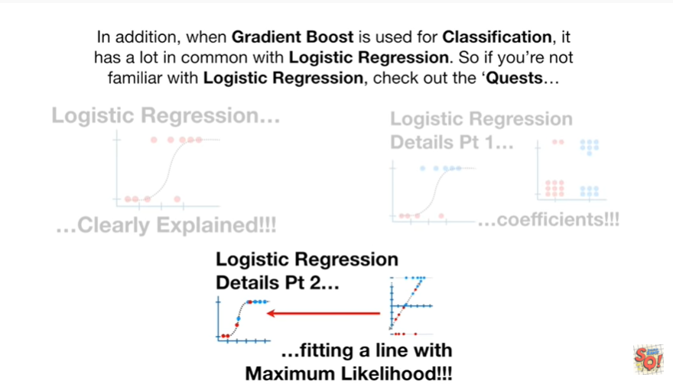

check out the quests.

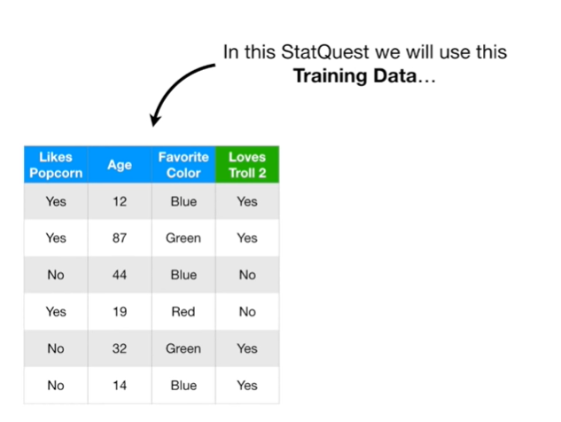

In this stat quest we will use this training data

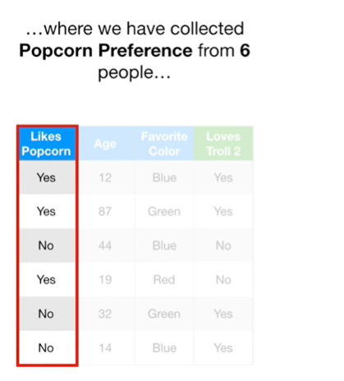

where we have collected popcorn preference from six people

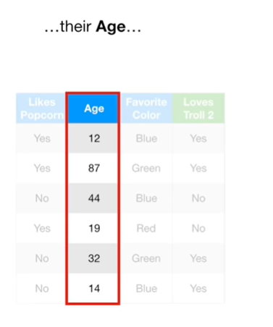

their age

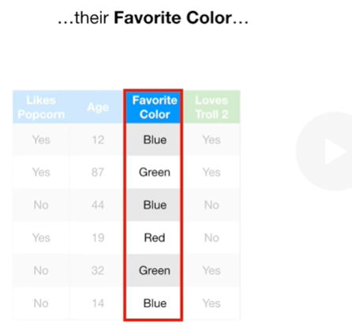

their favorite color

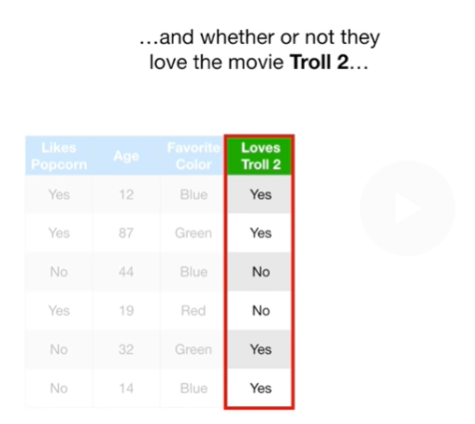

and whether or not they loved the movie troll 2

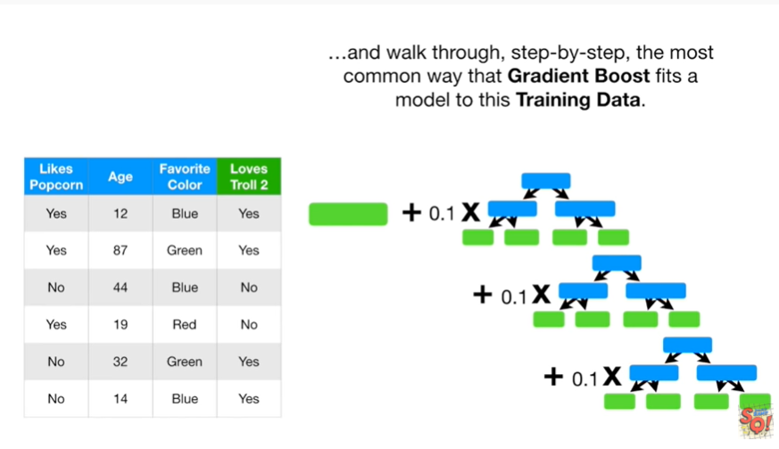

and walk through, step by step, the most common way that gradient boost fits a model to this training data.

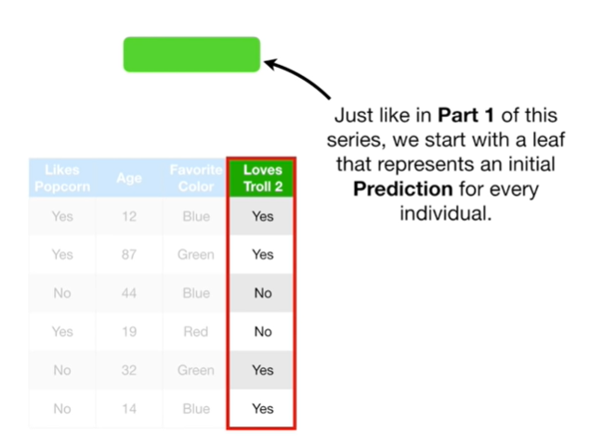

Just like in part one of this series, we start with a leaf that represents an initial prediction for every individual.

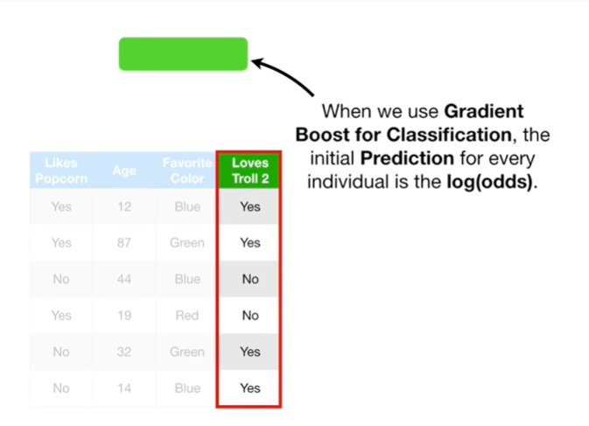

When we use gradient boost for classification, the initial prediction for every individual is the log of the odds.

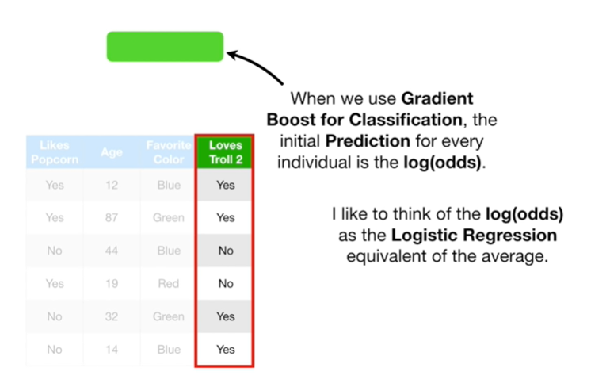

I like to think of the log of the odds as the logistic regression equivalent of the average.

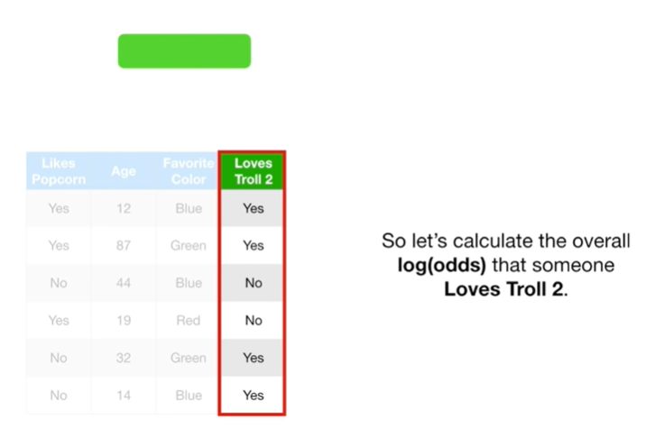

So let's calculate the overall log of the odds that someone loves troll 2.

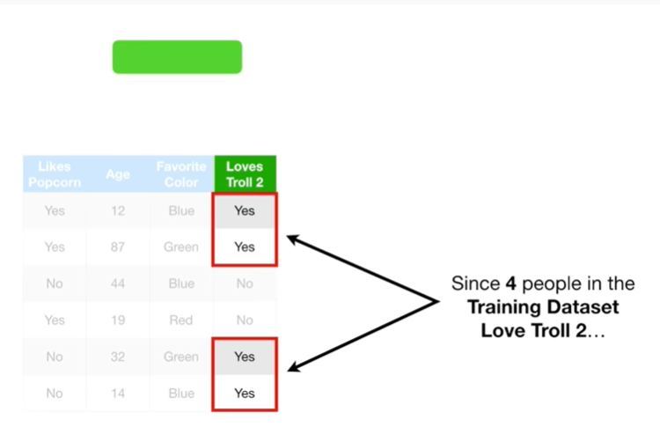

Since four people in the training dataset love troll 2

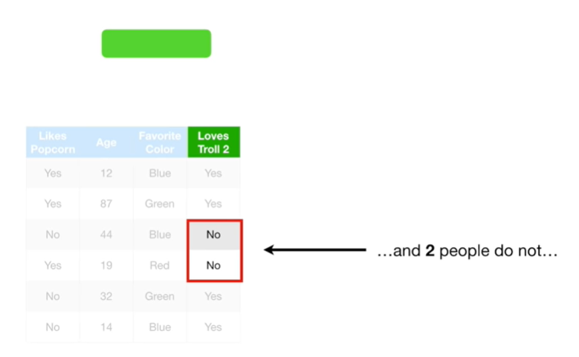

and two people do not

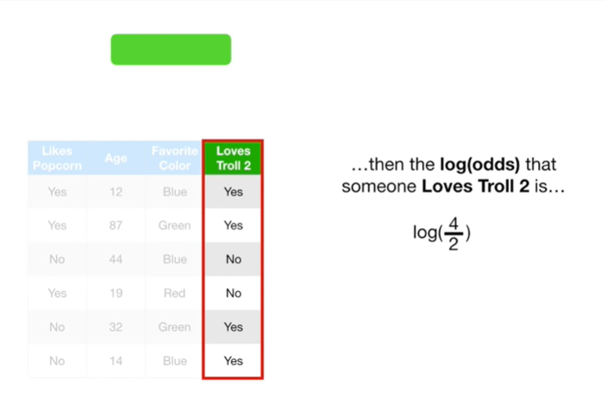

then the log of the odds that someone loves troll two is the log of 4 divided by two

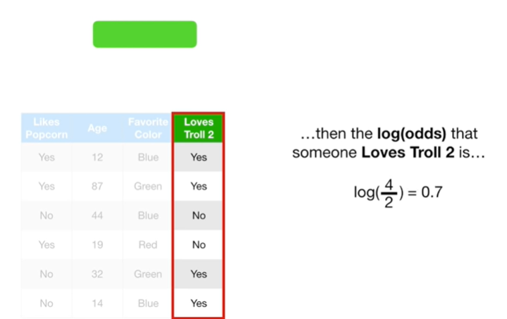

which equals zero point seven

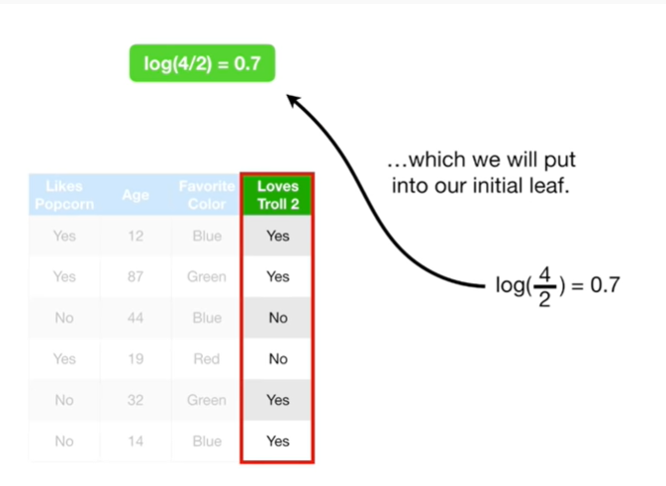

which we will put into our initial leaf.

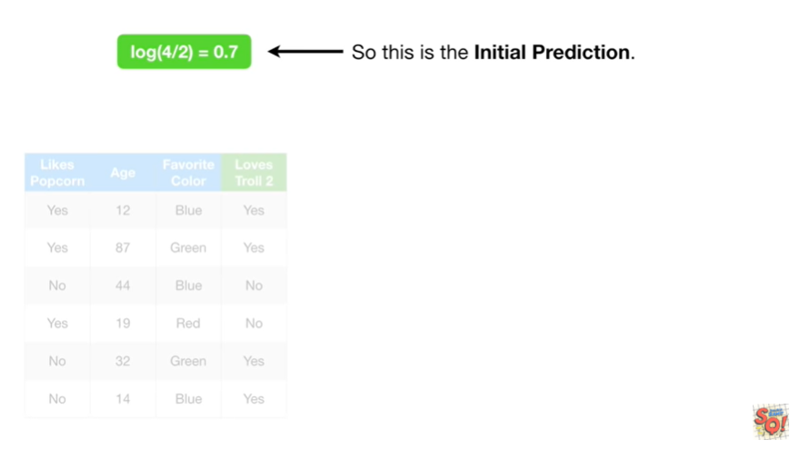

So this is the initial prediction.

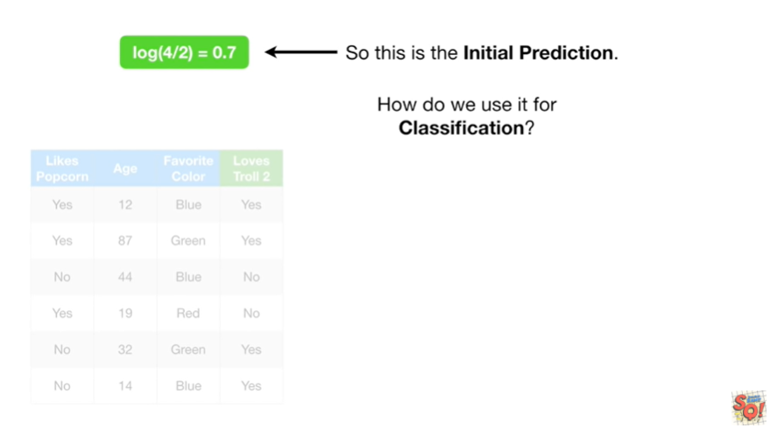

How do we use it for classification ?

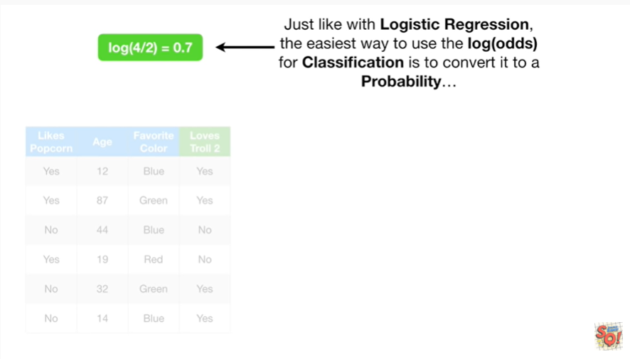

Just like with logistic regression, the easiest way to use the log of the odds for classification is to convert it to a probability

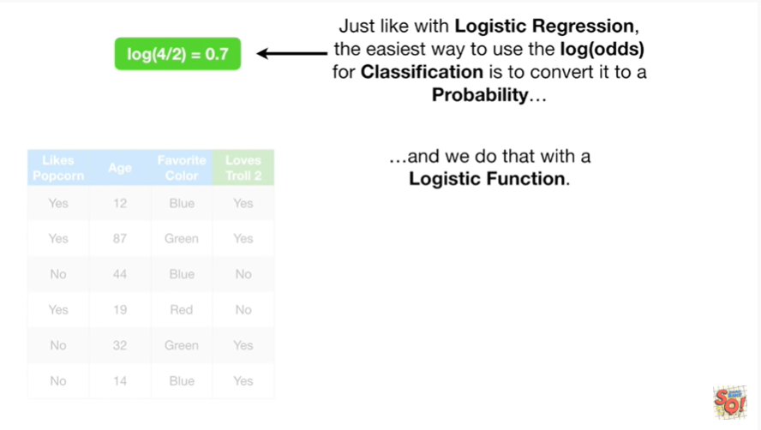

and we do that with the logistic function.

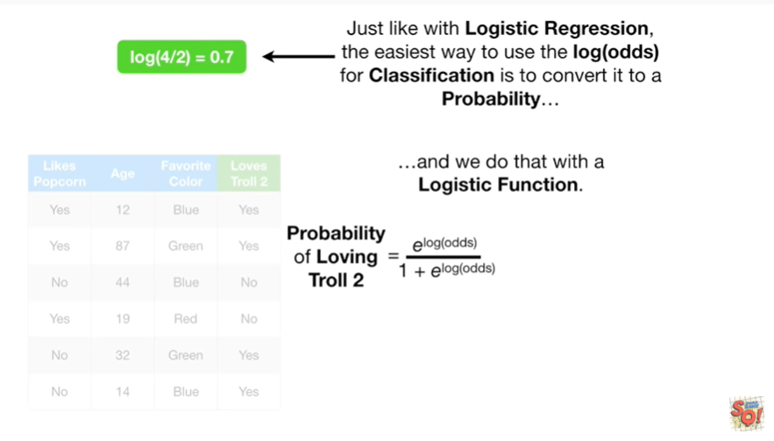

The probability of loving troll 2 equals e to the log odds divided by 1 plus e to the log odds.

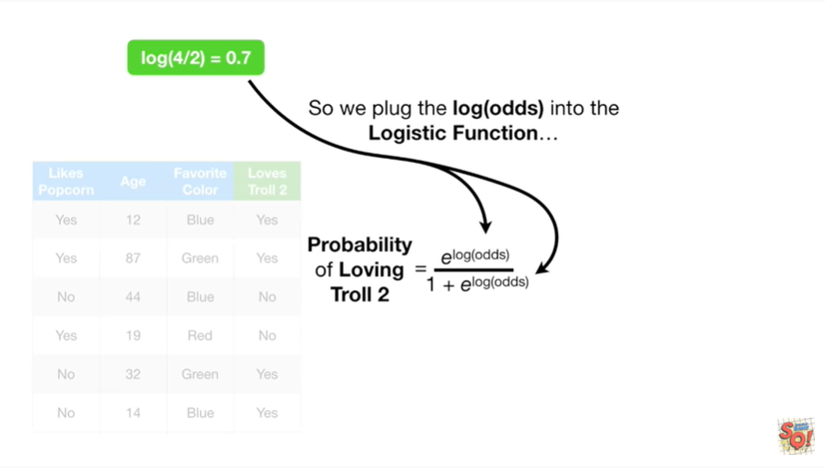

So we plug in the log of the odds into the logistic function

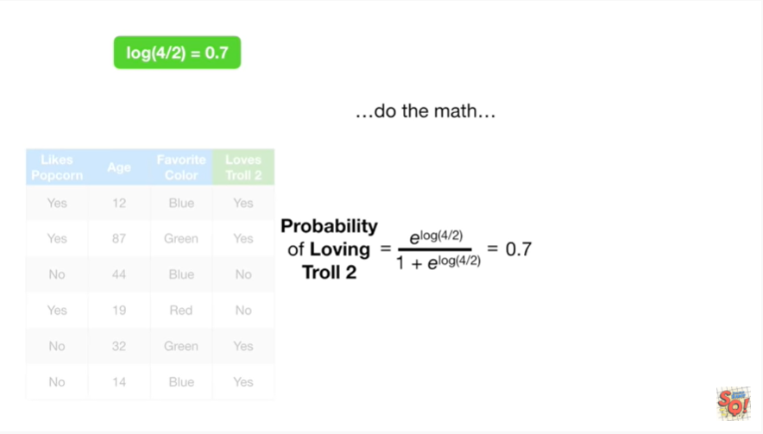

do the math

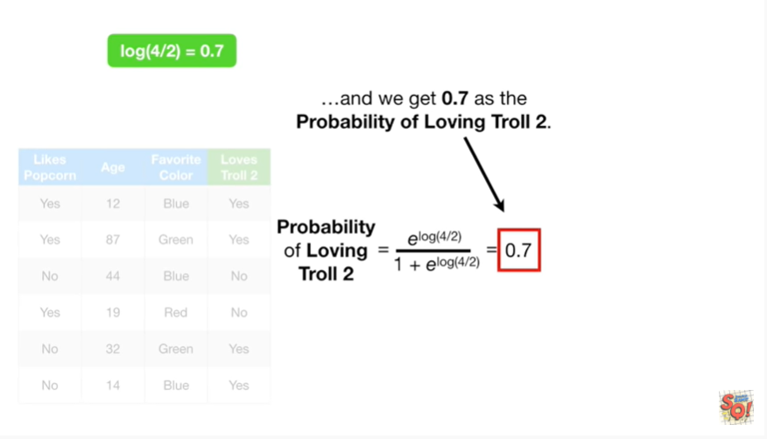

and we get 0.7 as the probability of loving troll 2.

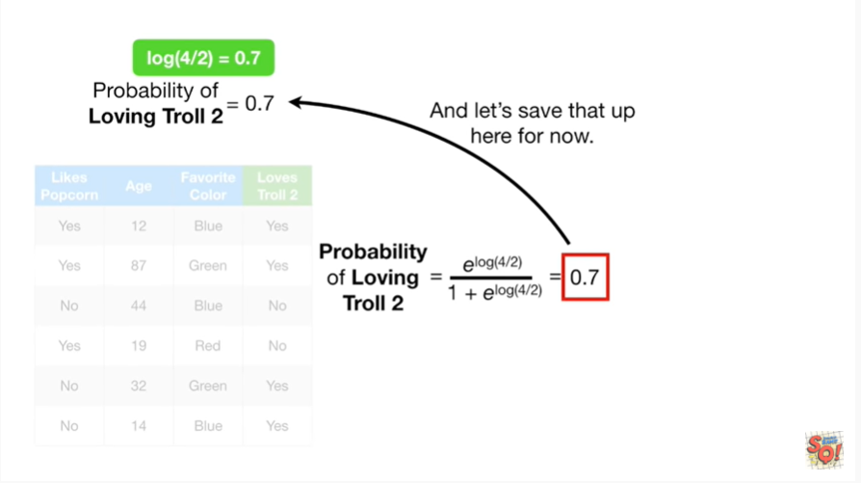

And let's save that up here for now.

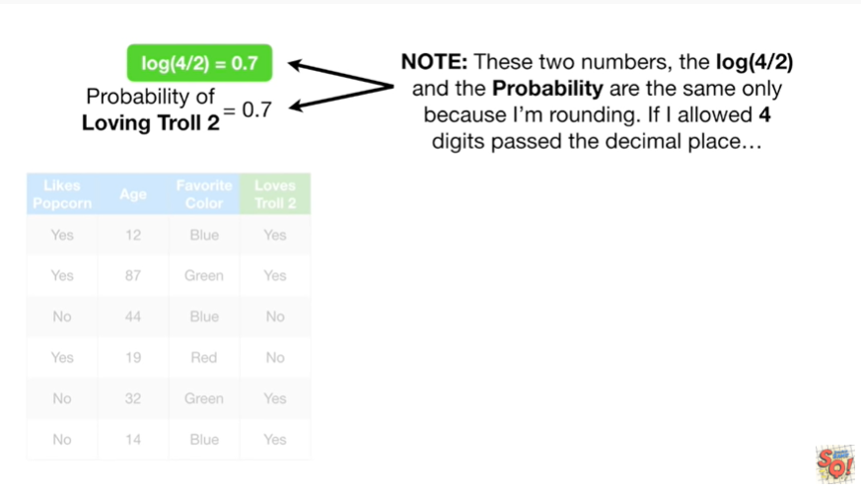

Note : these two numbers, the log of 4 divided by 2 and the probability are the same only because I'm rounding.

If I allowed four digits past the decimal place

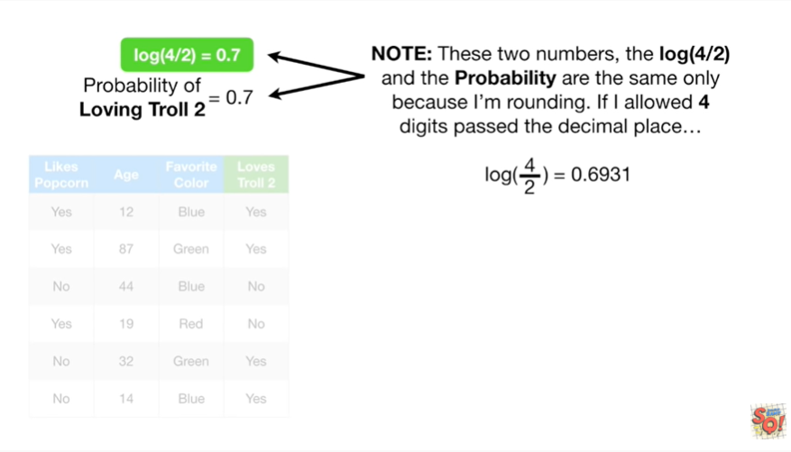

then the log of 4 divided by 2 would equal 0.6931

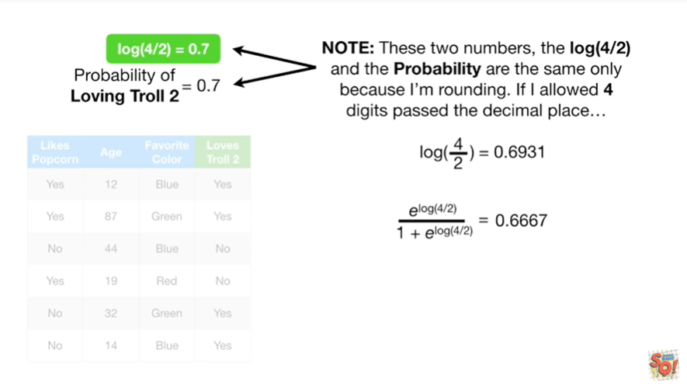

and the probability would equal zero point 6 6 6 7.

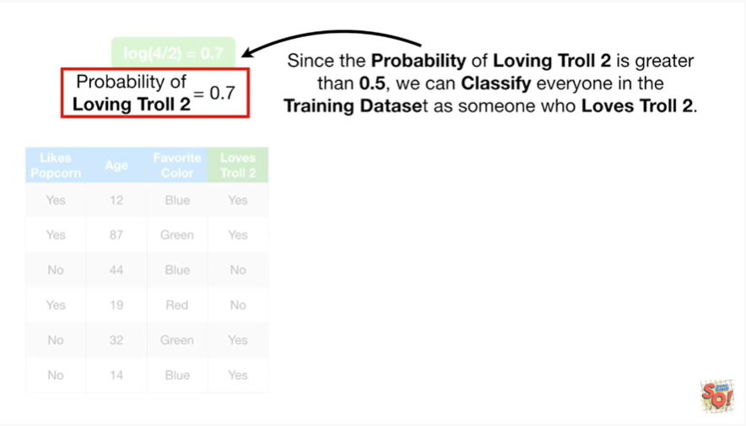

Since the probability of loving troll 2 is greater than 0.5, we can classify everyone in the training dataset as someone who loves troll 2.

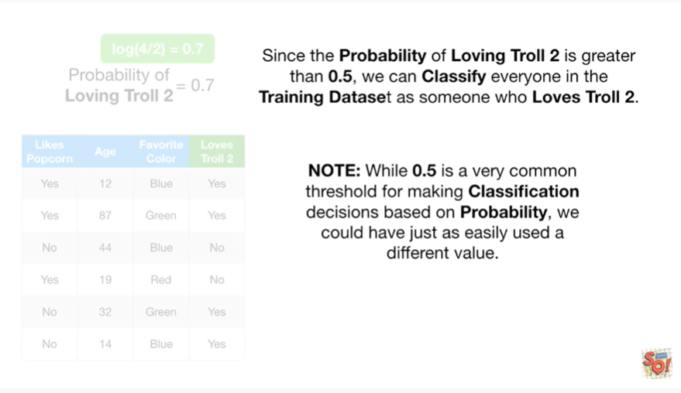

Note : while 0.5 is a very common threshold for making classification decisions based on probability, we could have just as easily used a different value.

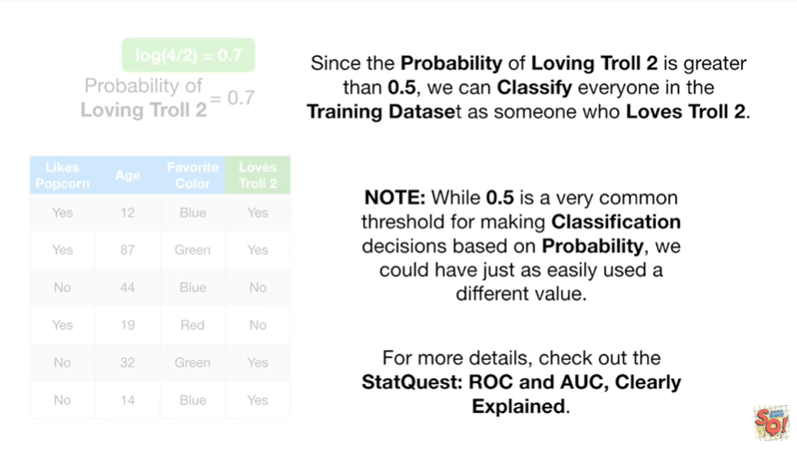

For more details check out the stat quest ROC and AUC, clearly explained.

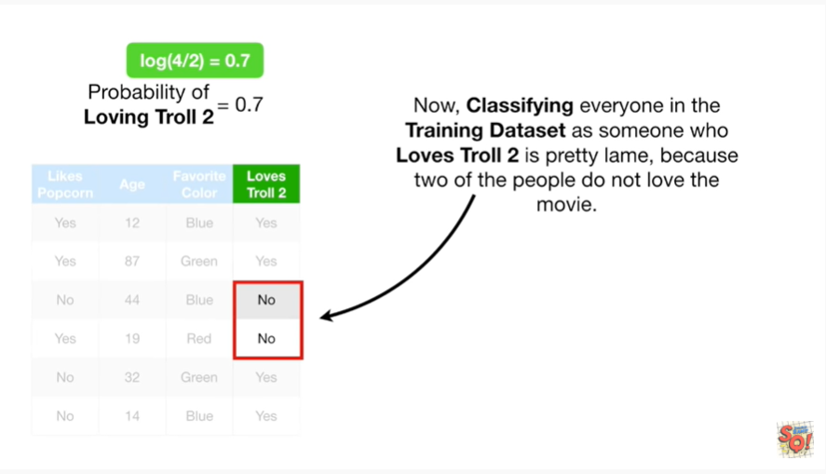

Now, classifying everyone in the training dataset as someone who loves troll 2 is pretty lame, because two of the people do not love the movie.

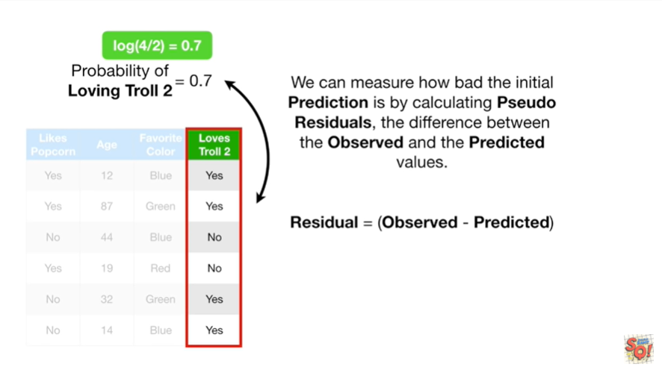

We can measure how bad the initial prediction is by calculating pseudo residuals, the difference between the observed and the predicted values.

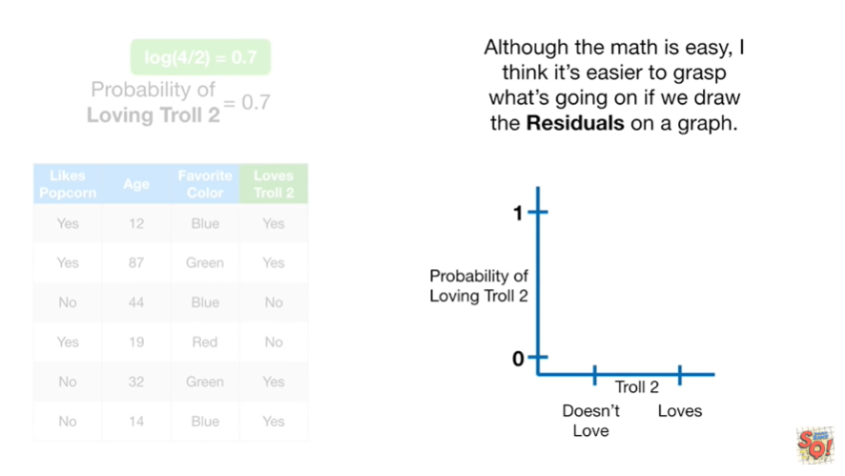

Although the math is easy, I think it's easier to grasp what's going on if we draw the residuals on a graph.

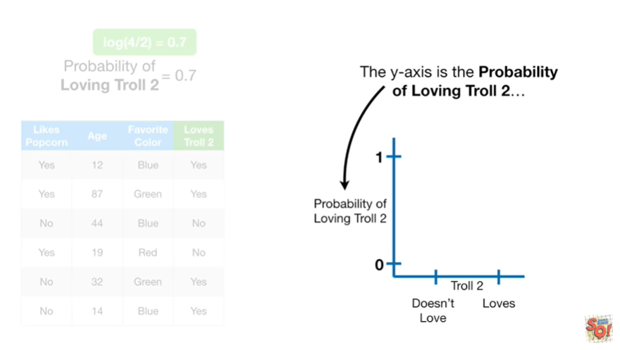

The y-axis is the probability of loving troll 2.

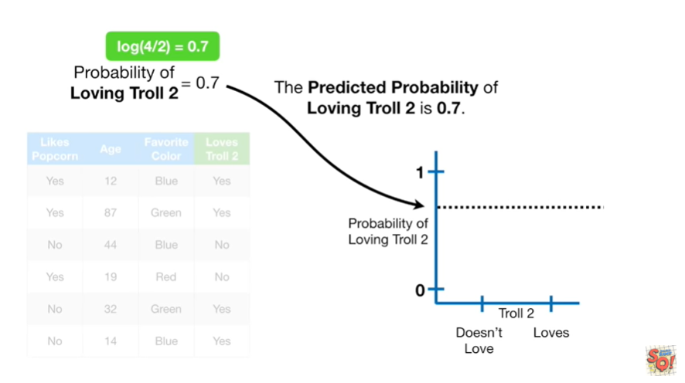

The predicted probability of loving troll 2 is 0.7.

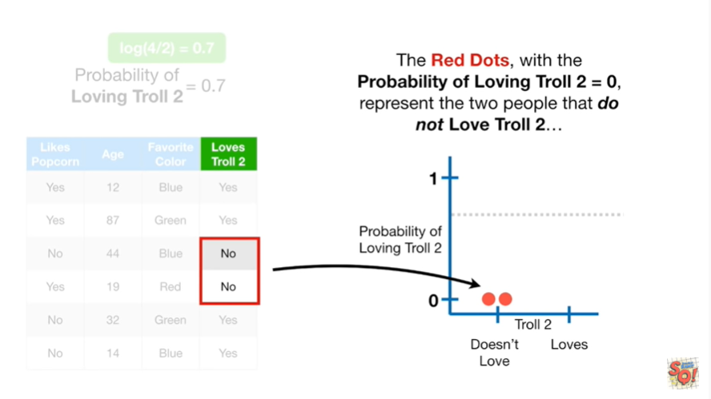

The red dots with the probability of loving troll to equal to zero, represent the two people that do not love troll 2.

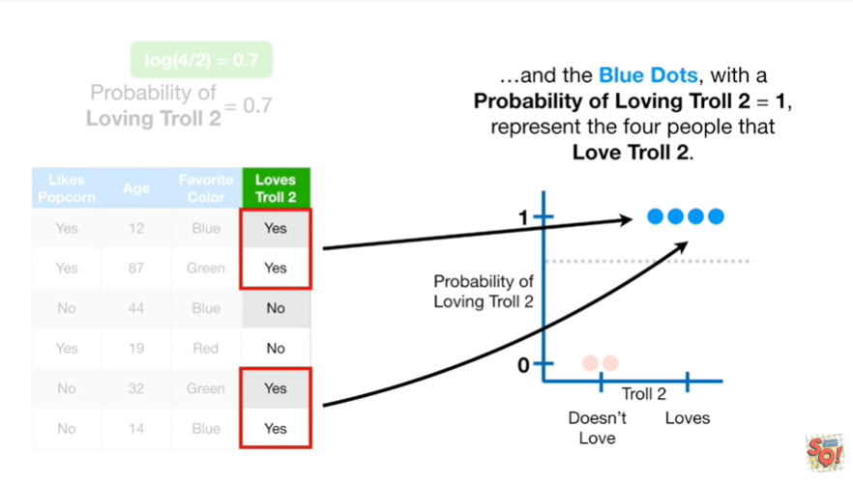

And the blue dots, with the probability of loving troll 2 equal to 1, represent the four people that love troll 2.

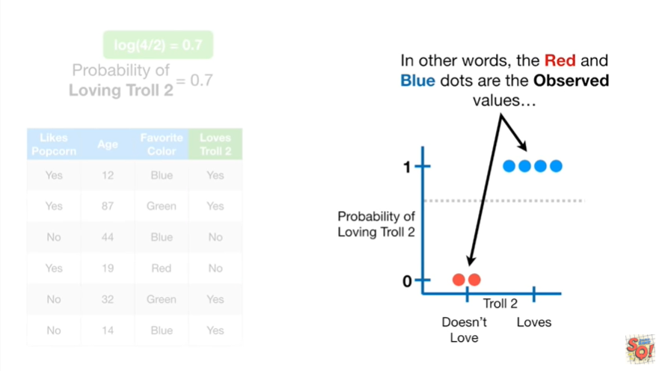

In other words the red and blue dots are the observed values

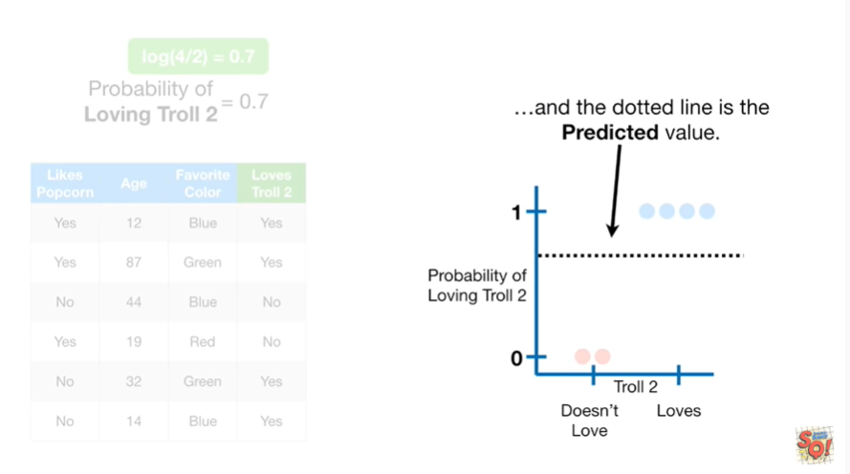

and the dotted line is the predicted value.

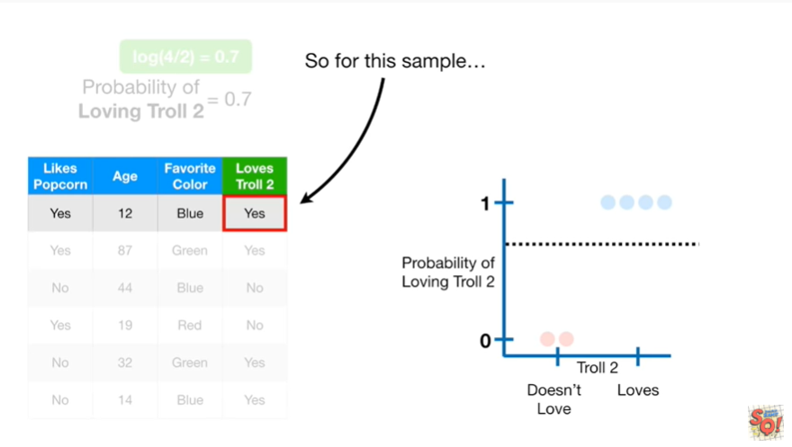

So for this sample

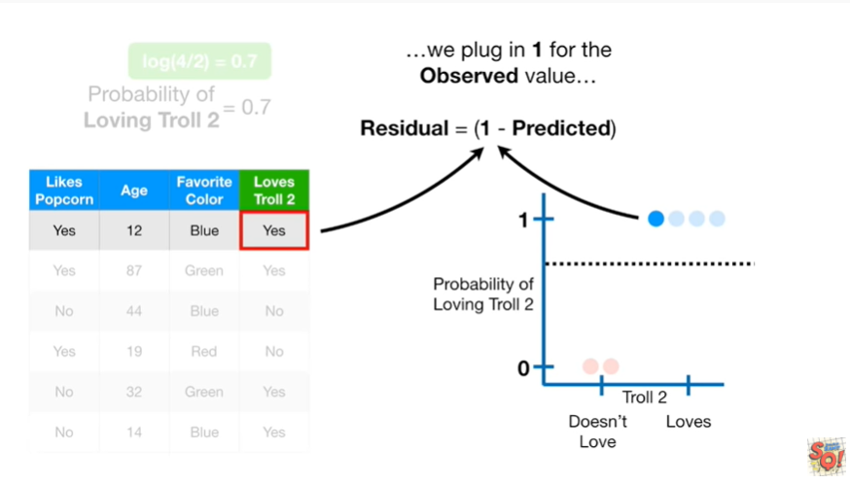

we plug in one for the observed value

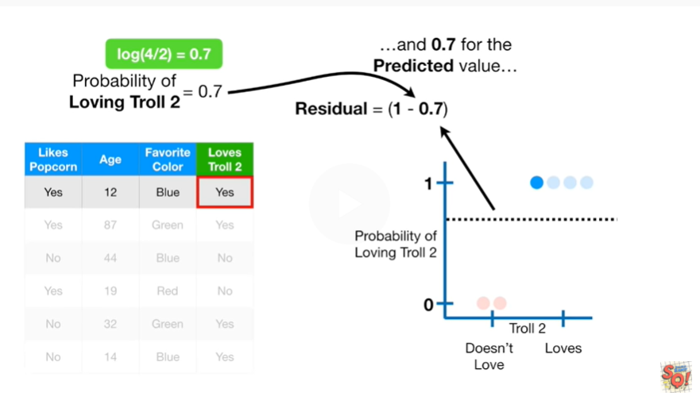

and 0.7 for the predicted value

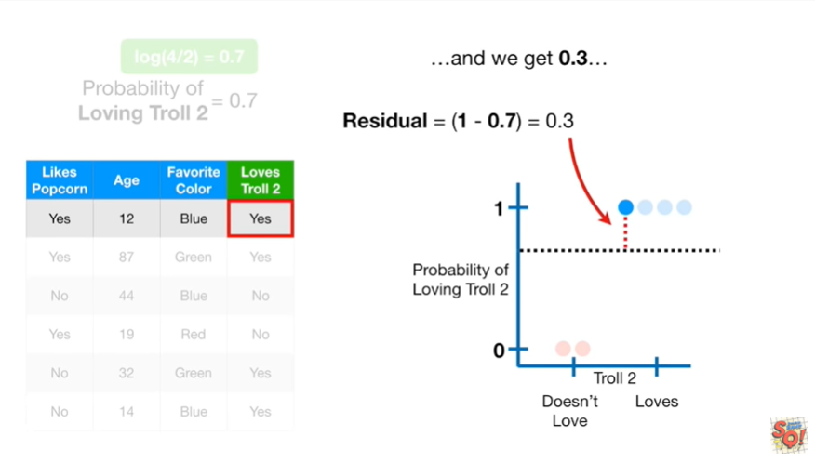

and we get 0.3

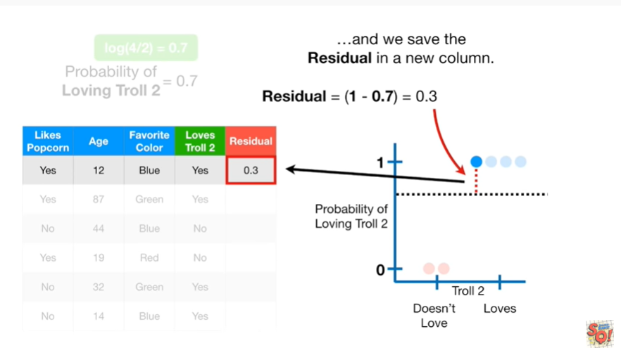

and we save the residual in a new column.

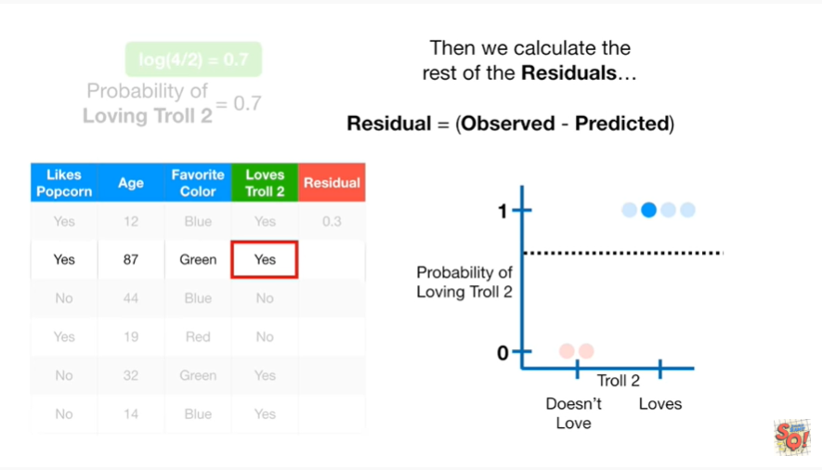

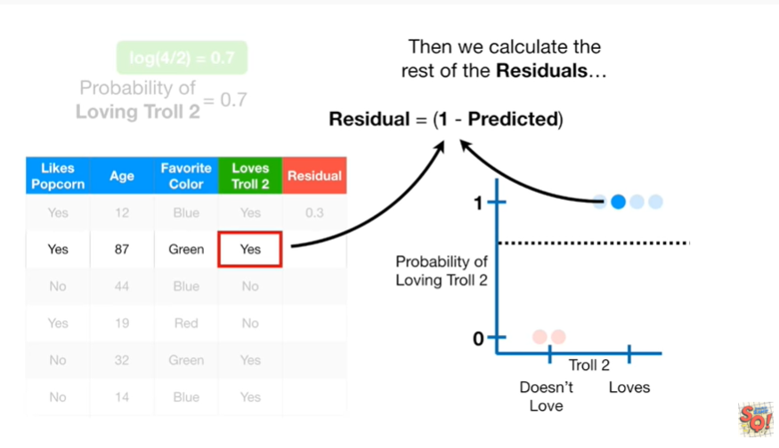

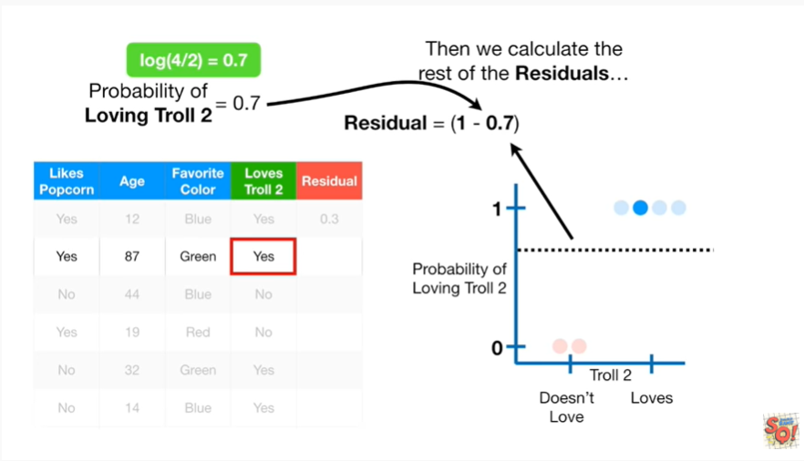

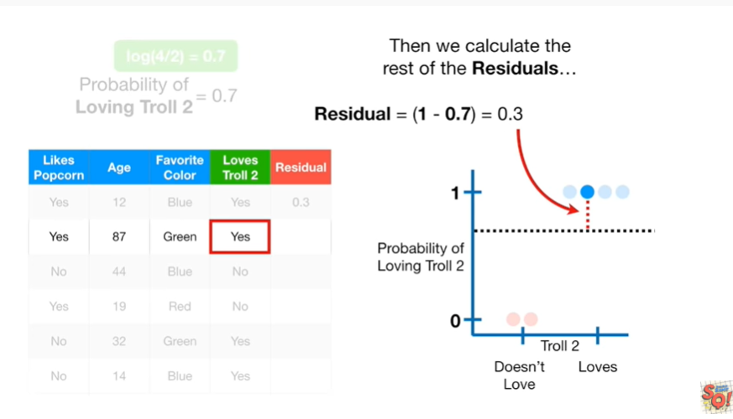

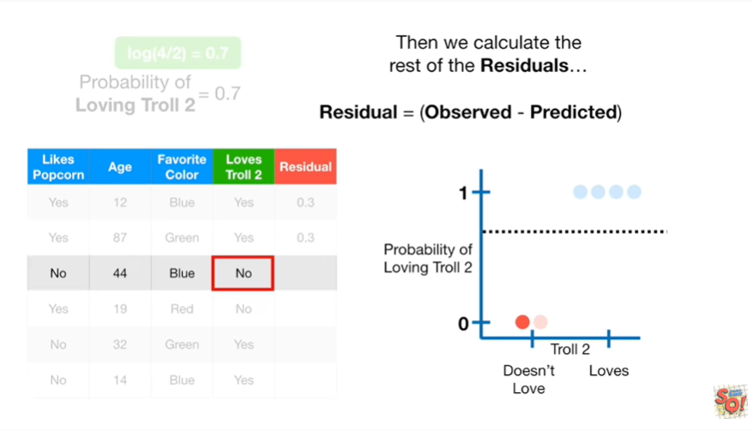

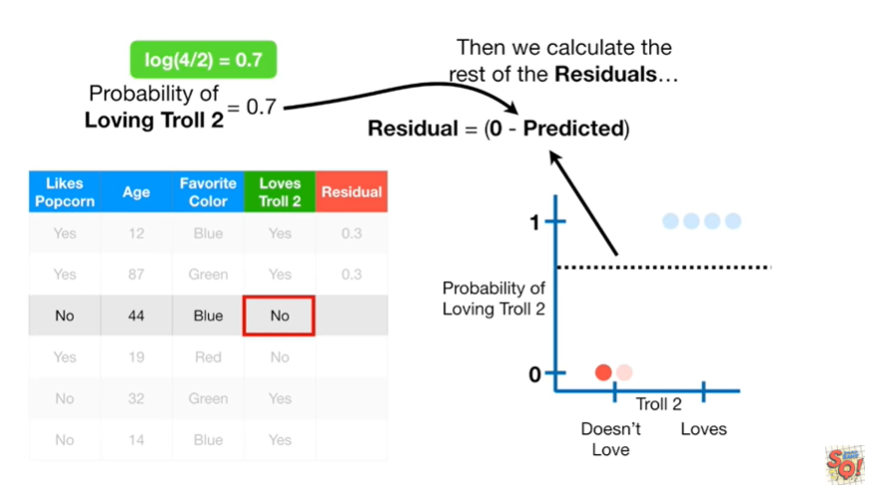

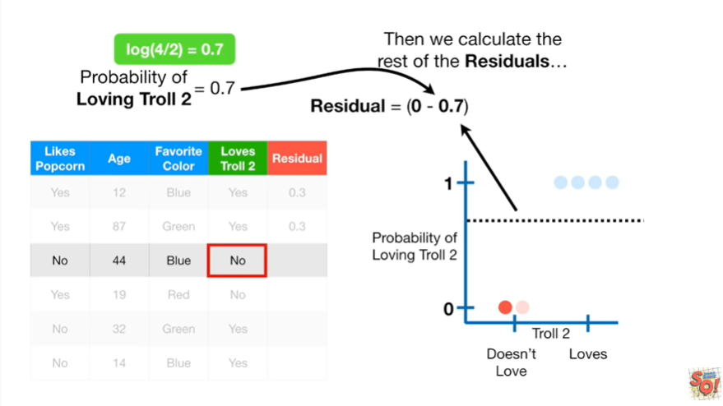

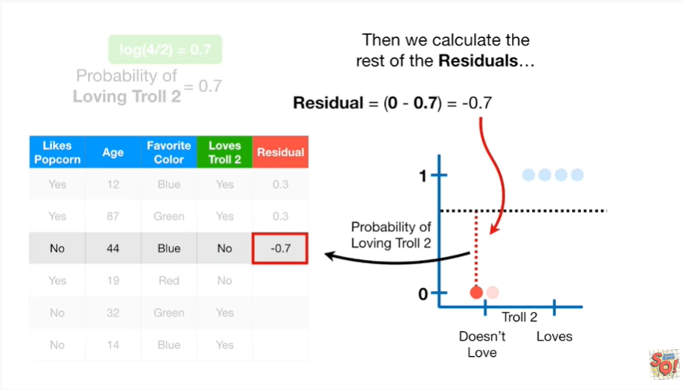

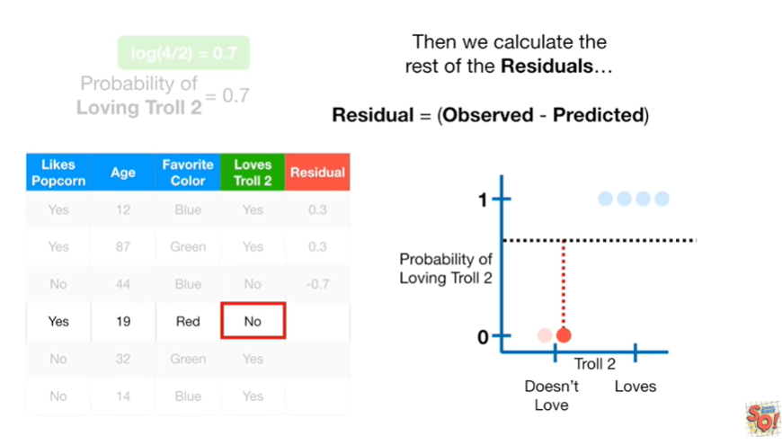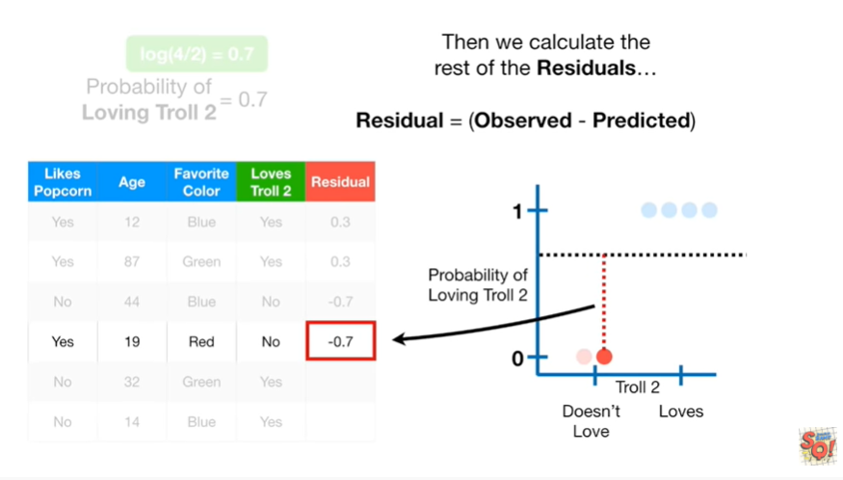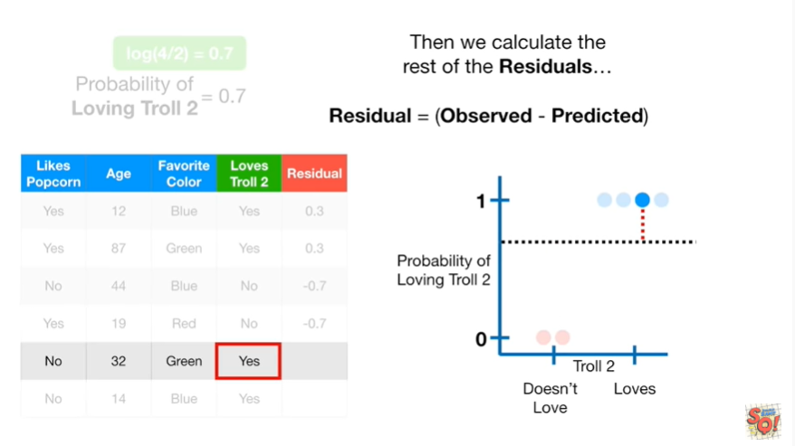

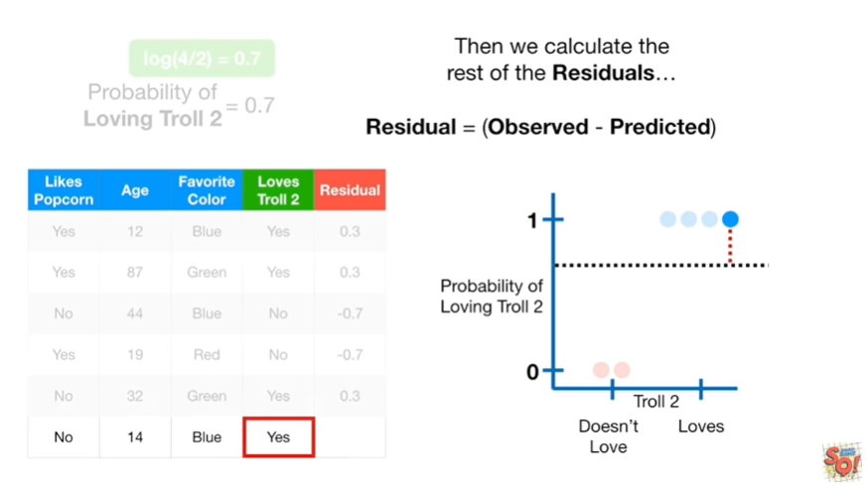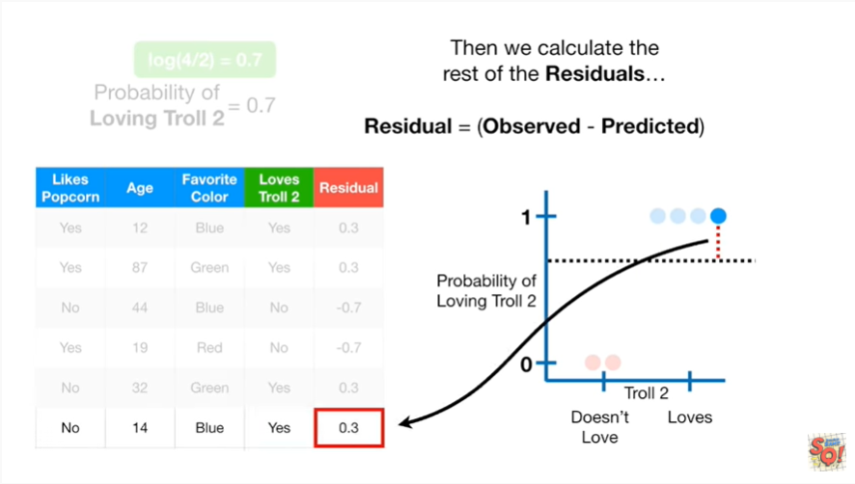

Then we calculate the rest of the residuals.

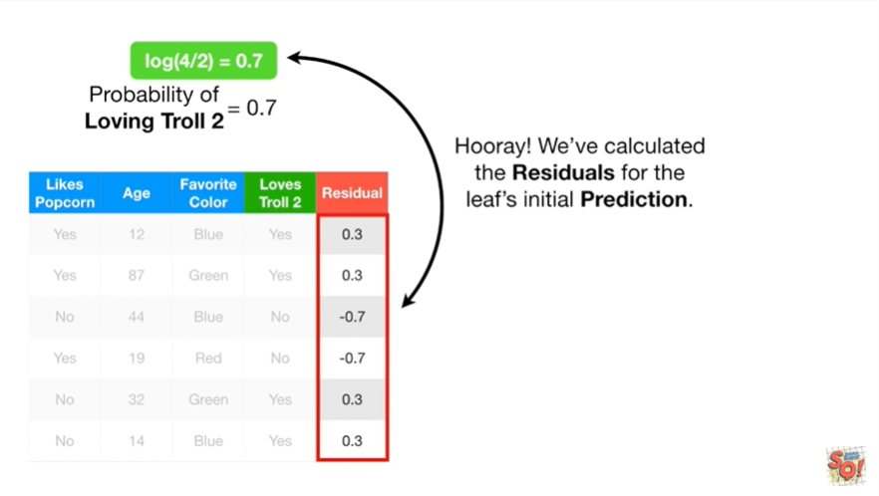

Hooray !!!

We've calculated the residuals for the Leafs initial prediction.

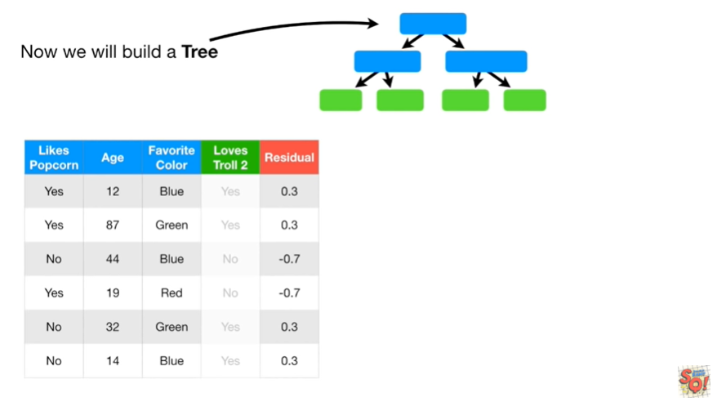

Now we build a tree

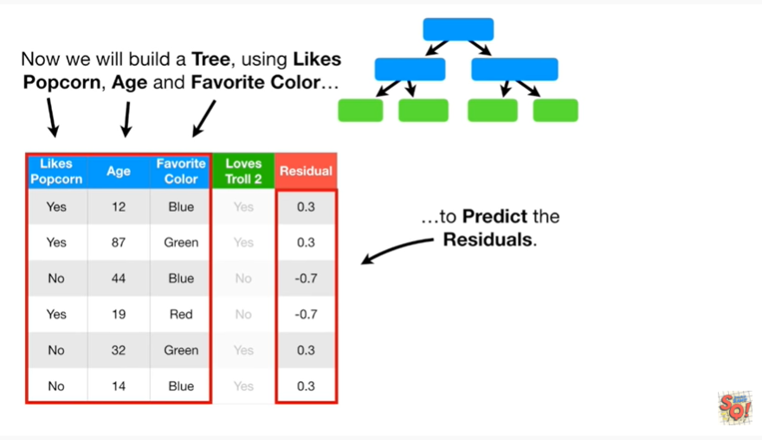

using likes popcorn age and favorite color to predict the residuals.

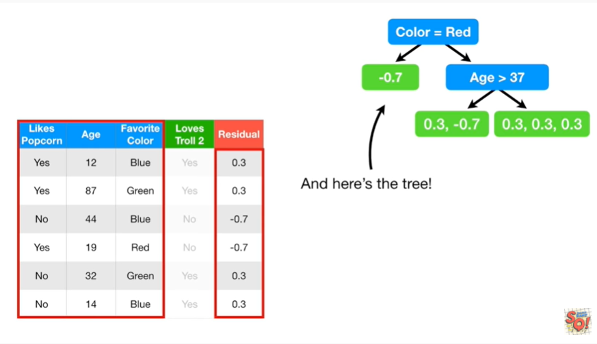

And here's the tree.

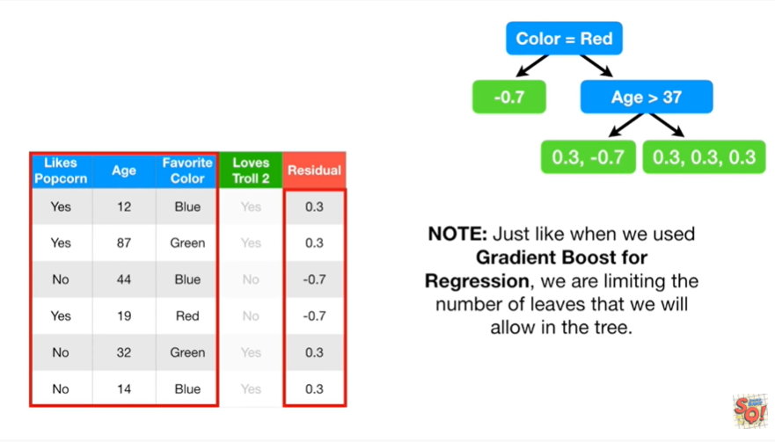

Note : just like when we used gradient boost for regression, we are limiting the number of leaves that we will allow in the tree.

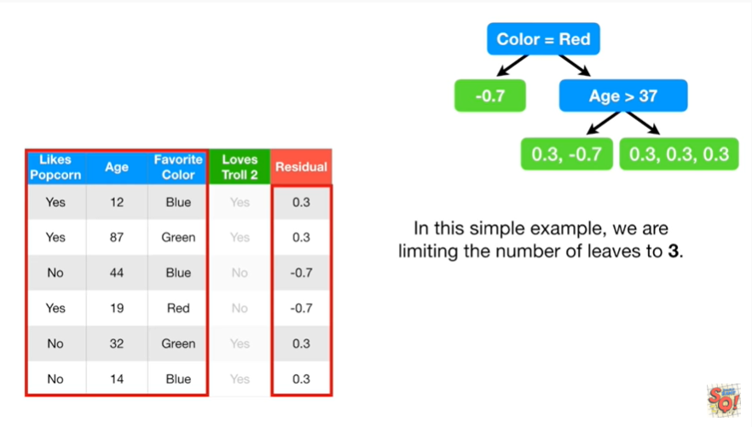

In this simple exampl,e we are limiting the number of leaves to three.

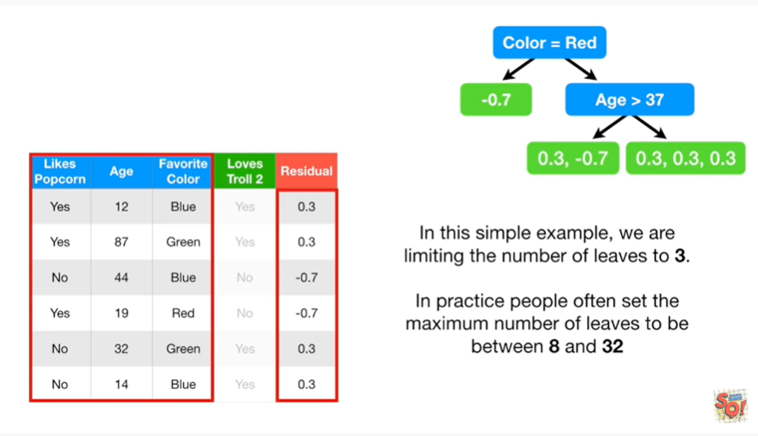

In practice, people often set the maximum number of leaves to be between 8 and 32.

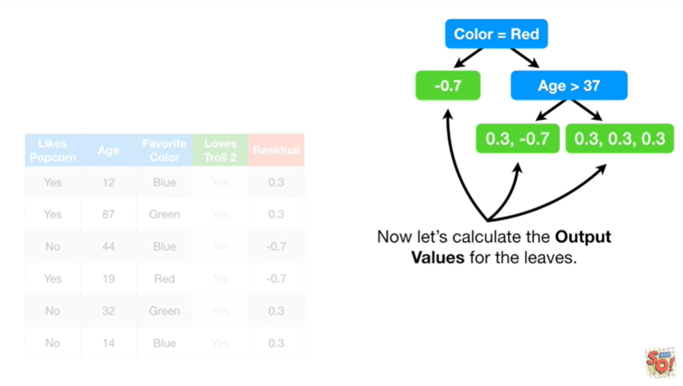

Now let's calculate the output values for the leaves.

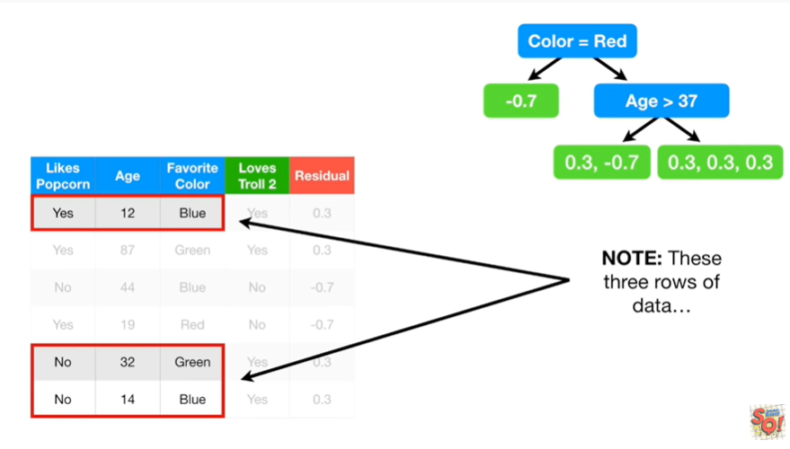

Note : these three rows of data

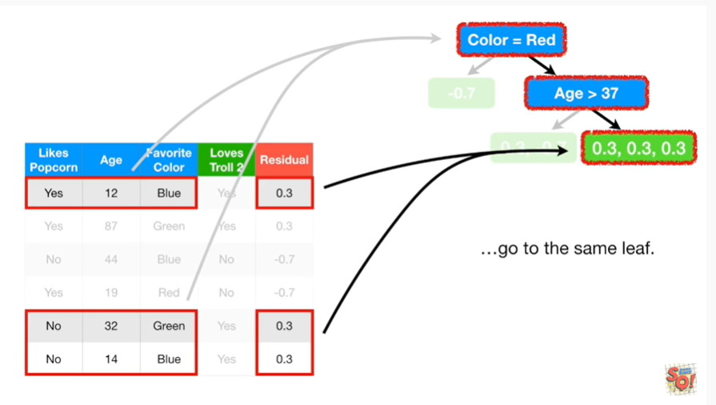

go to the same leaf.

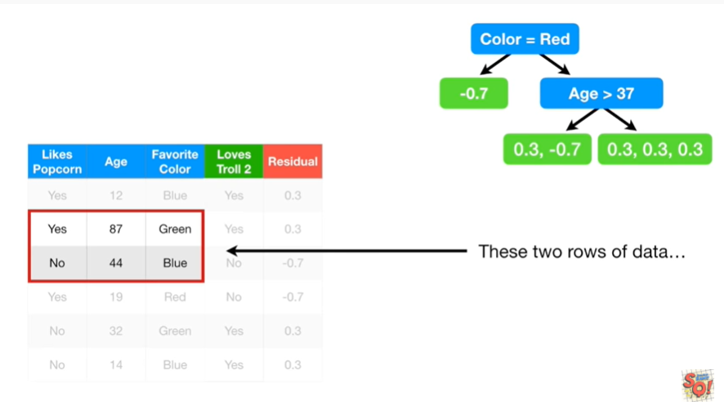

These two rows of data

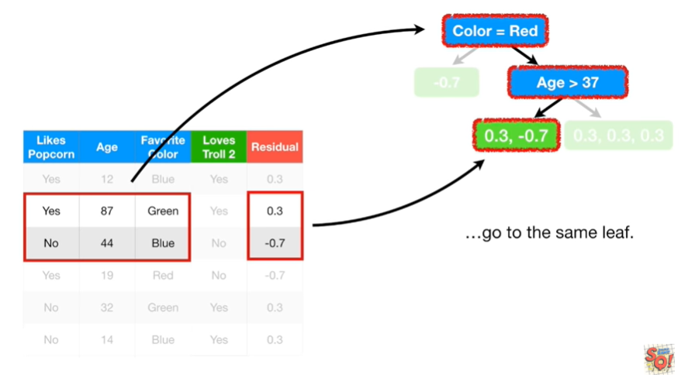

go to the same leaf.

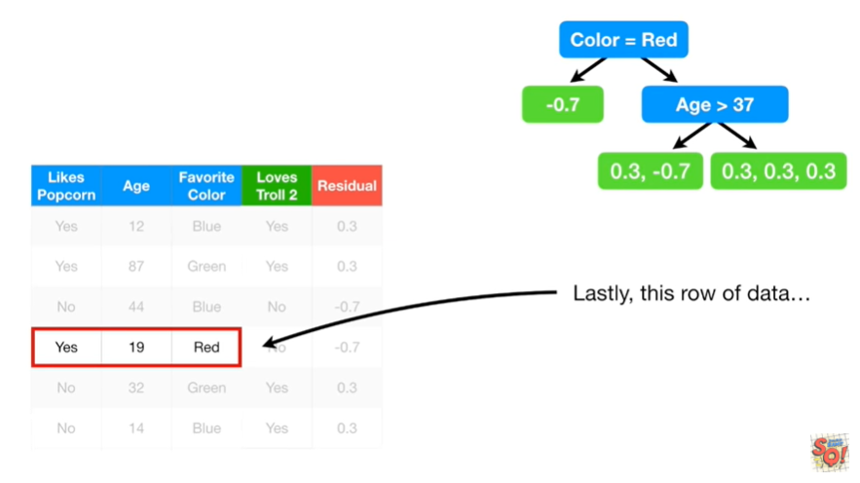

Lastly, this row of data

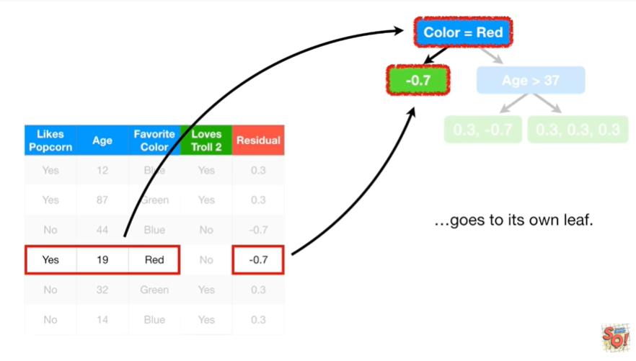

goes to its own leaf.

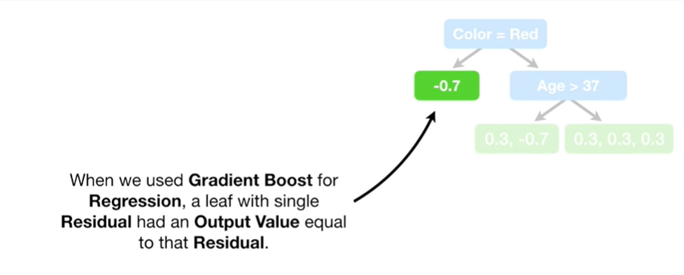

When we used gradient boost for regression a leaf with a single residual had an output value equal to that residual.

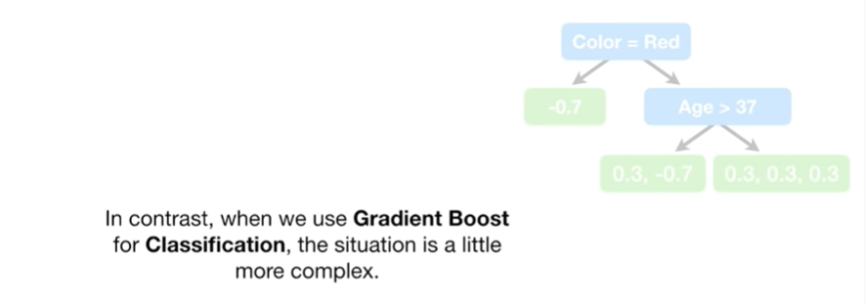

In contrast, when we use gradient boost for classification the situation is a little more complex.

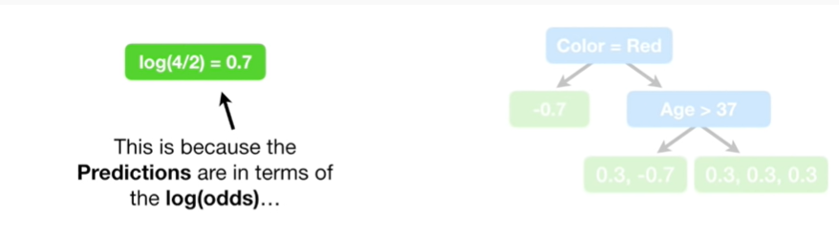

This is because the predictions are in terms of the log of the odds

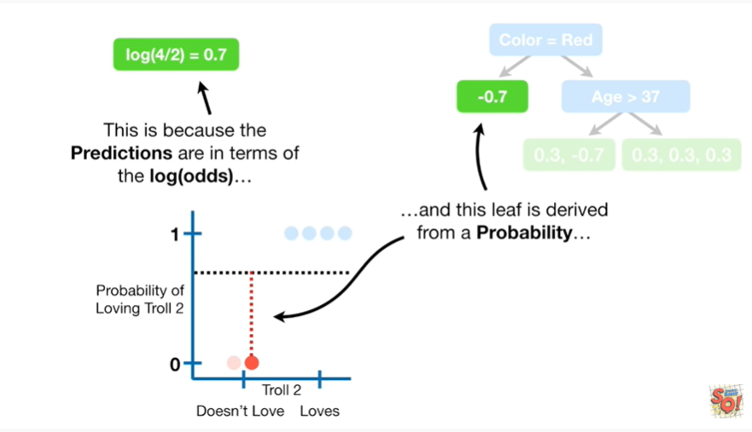

and this leaf is derived from a probability

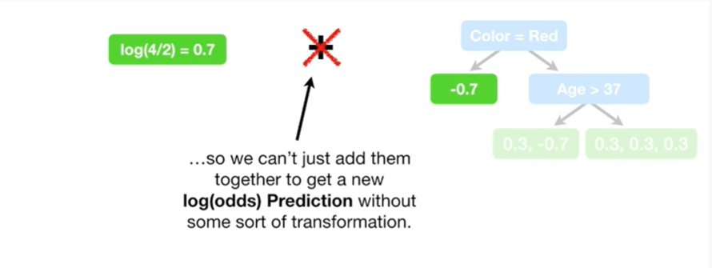

so we can't just add them together and get a new log of the odds prediction without some sort of transformation.

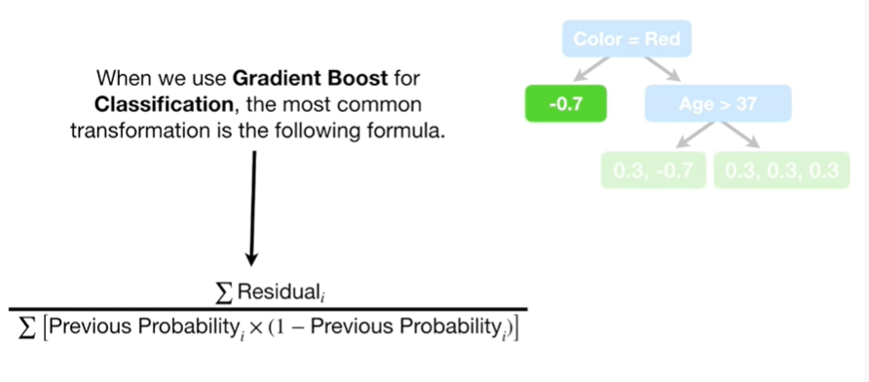

When we use gradient boosts for classification the most common transformation is the following formula.

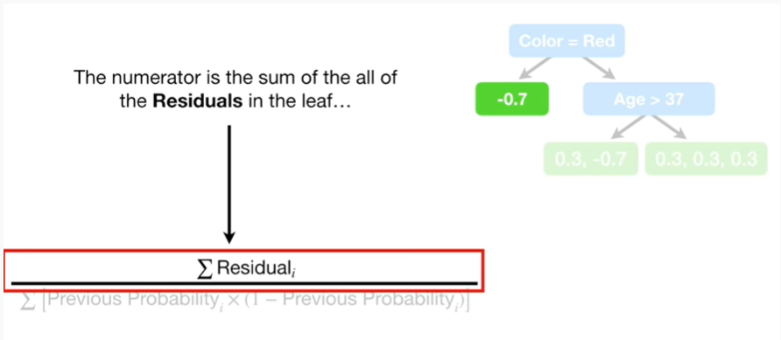

The numerator is the sum of all the residuals in the leaf

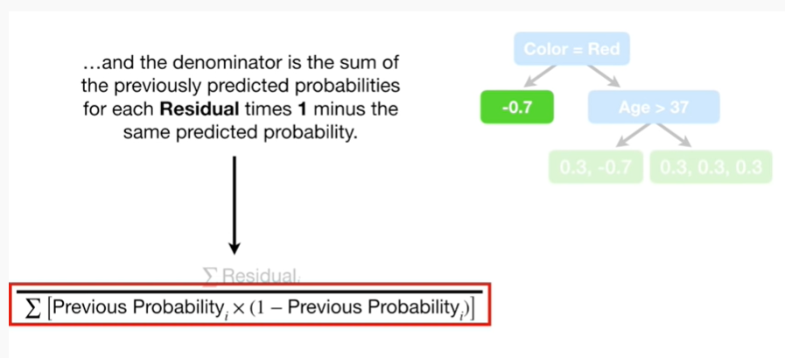

and the denominator is the sum of the previously predicted probabilities for each residual times one minus the same predicted probability.

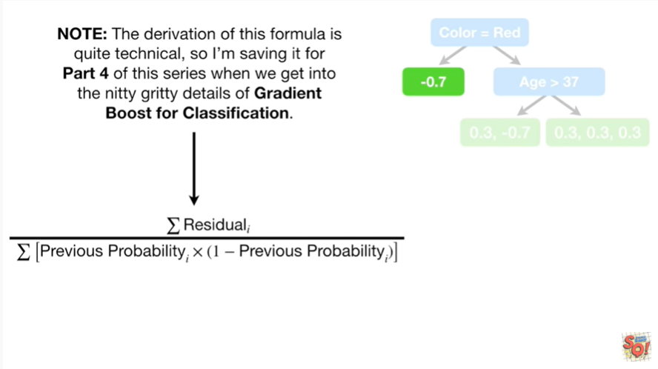

Note : the derivation of this formula is quite technical, so I'm saving it for part four of this series when we get into the nitty-gritty details of gradient boost for classification.

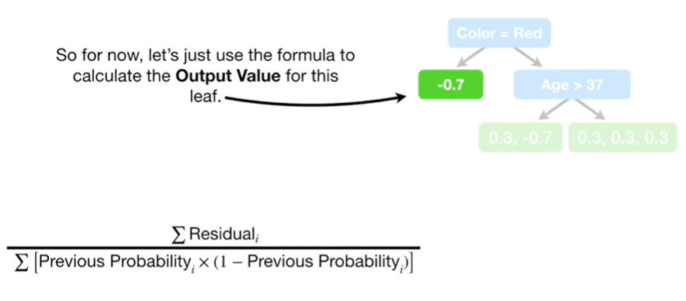

So for now let's just use the formula to calculate the output value for this leaf.

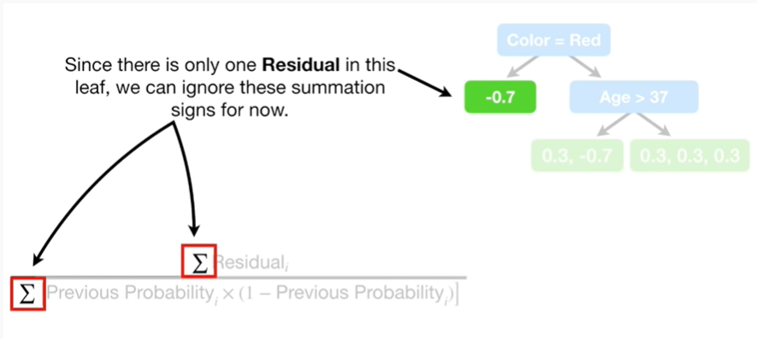

Since there is only one residual in this leaf, we can ignore these summation signs for now.

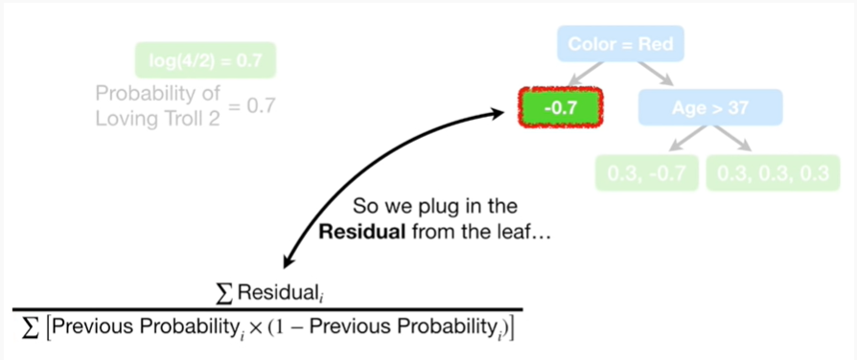

So we plug in the residual from the leaf

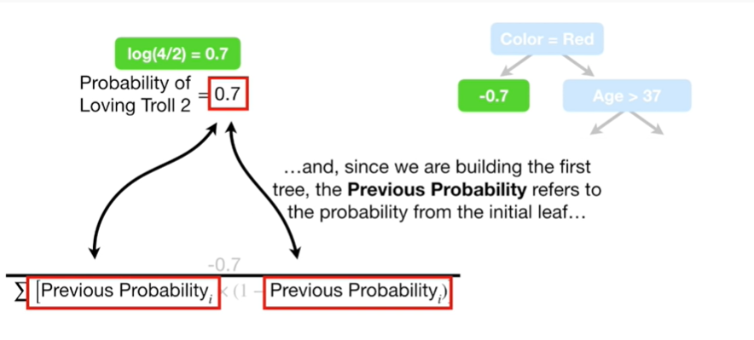

and since we are building the first tree the previous probability refers to the probability from the initial leaf

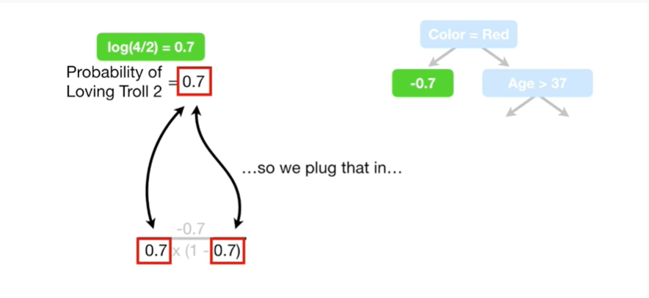

so we plug that in

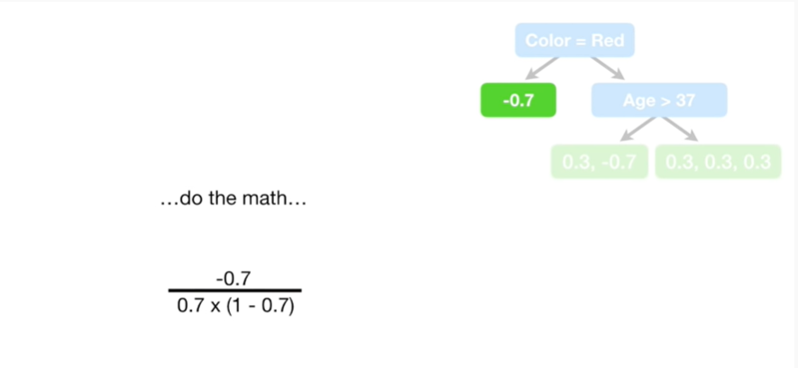

do the math

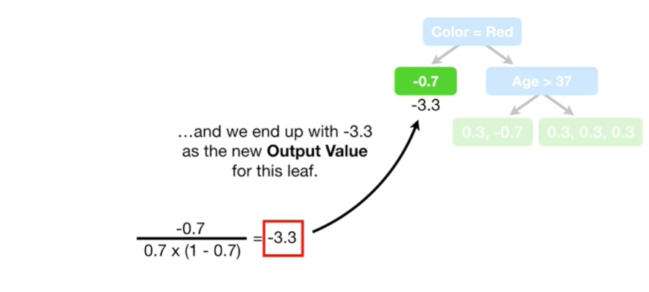

and we end up with negative three point three as the new output value for this leaf.

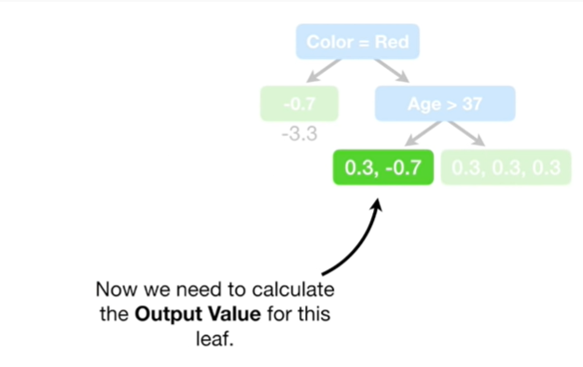

Now we need to calculate the output value for this leaf.

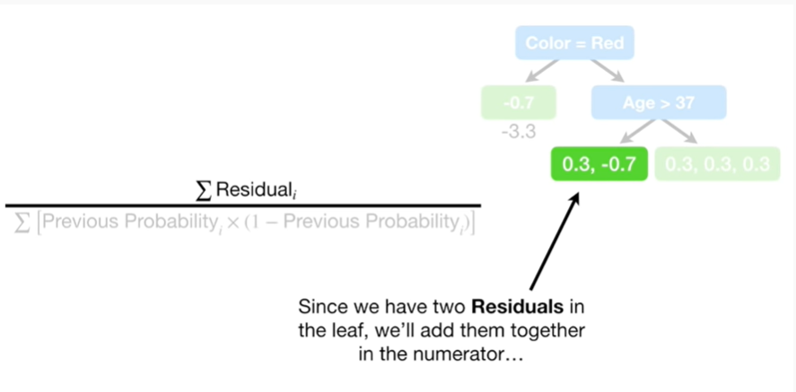

Since we have to residuals in the leaf

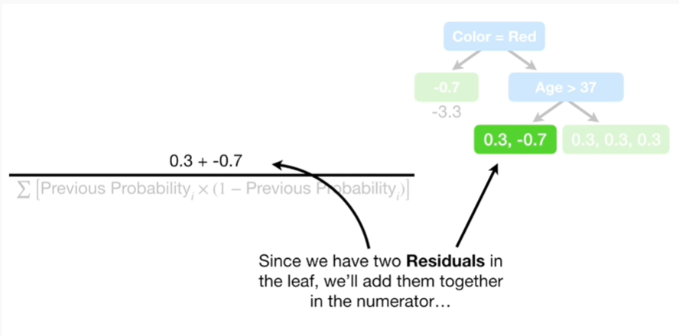

we'll add them together in the numerator

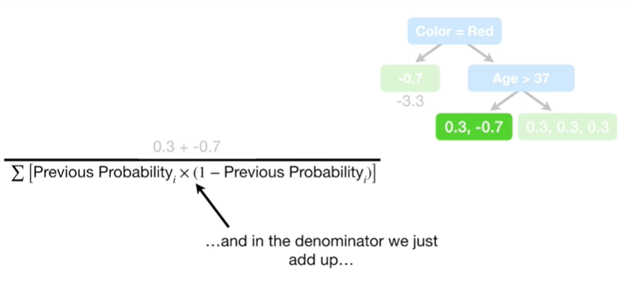

and in the denominator we just add up

the previous probability

times (1 minus the previous probability)

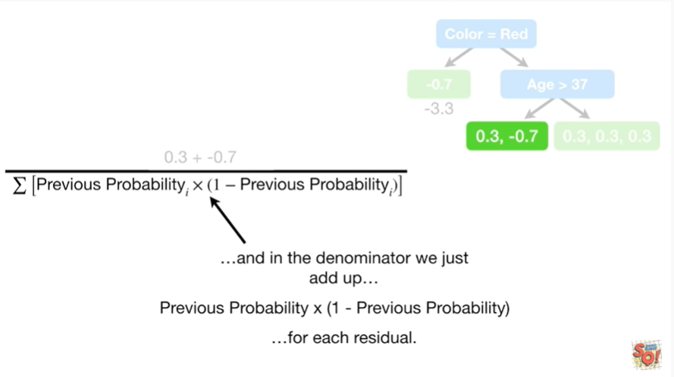

for each residual.

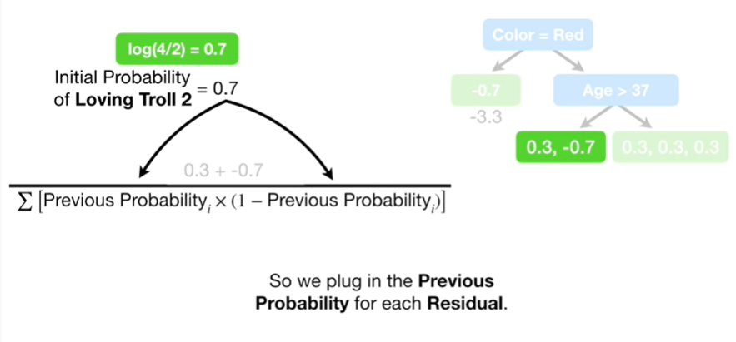

So we plug in the previous probability

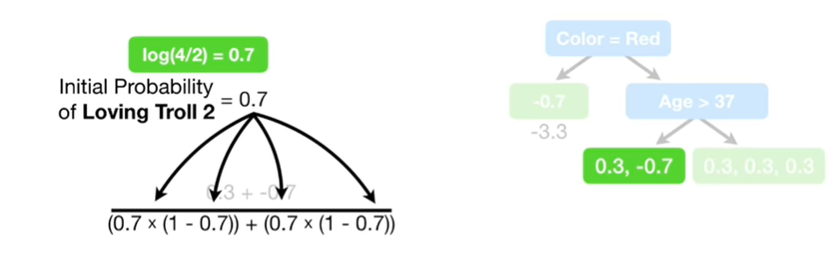

for each residual.

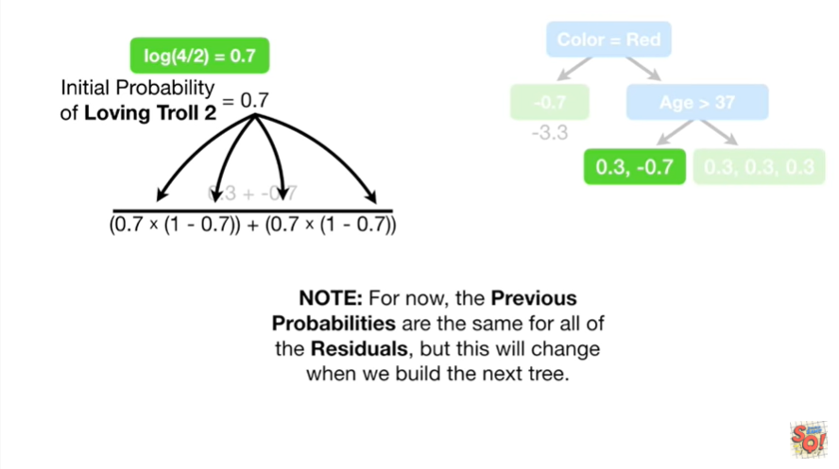

Note : for now, the previous probabilities are the same for all of the residuals, but this will change when we build the next tree.

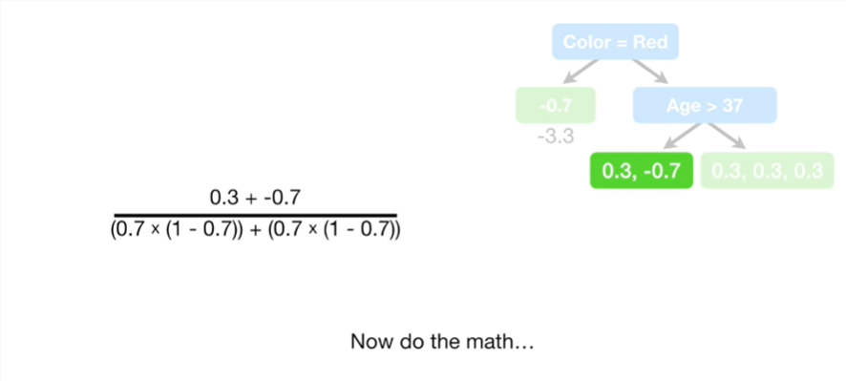

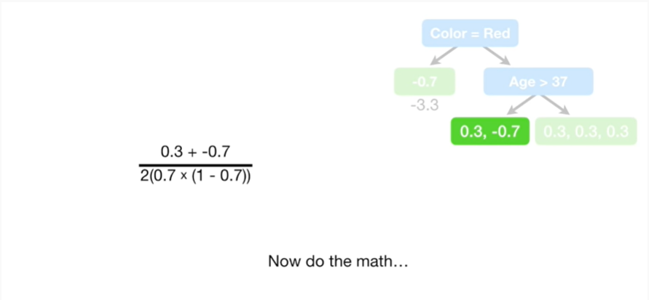

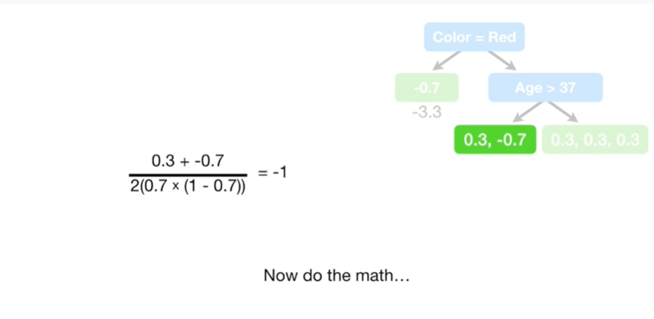

Now do the math

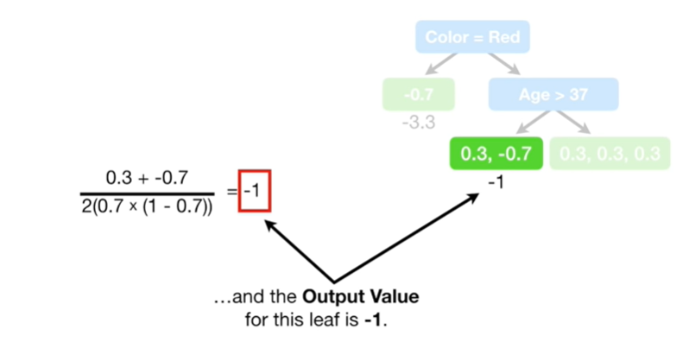

and the output value for this leaf is negative one.

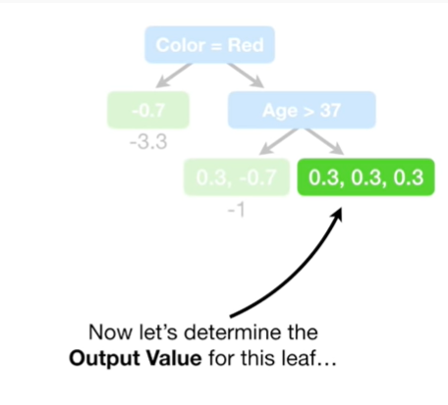

Now let's determine the output value for this leaf.

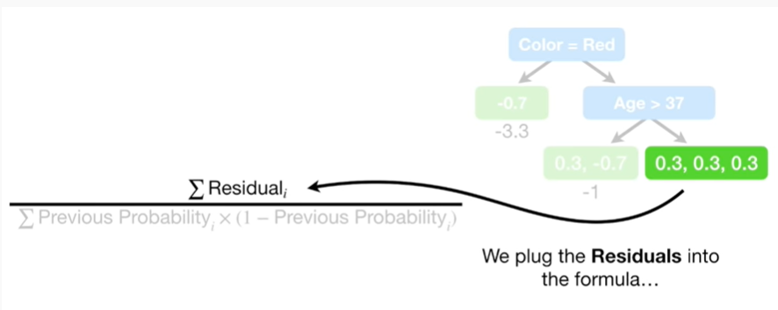

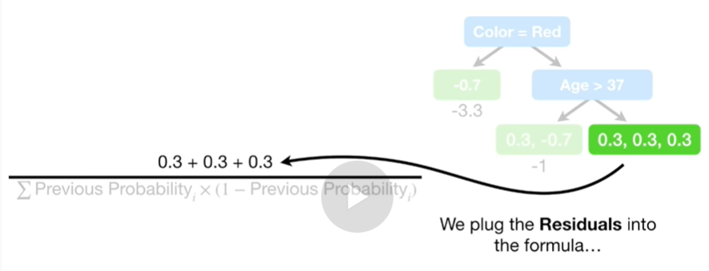

We plug the residuals into the formula

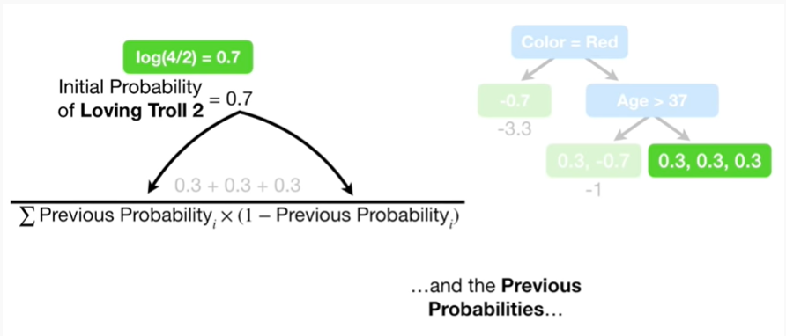

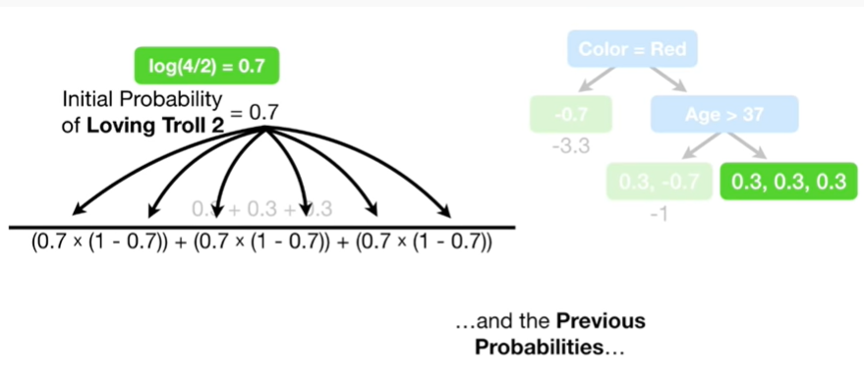

and the previous probabilities

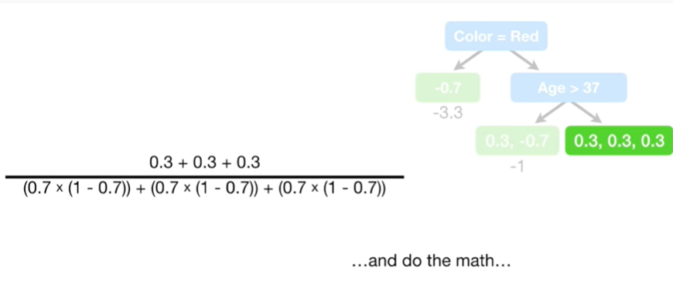

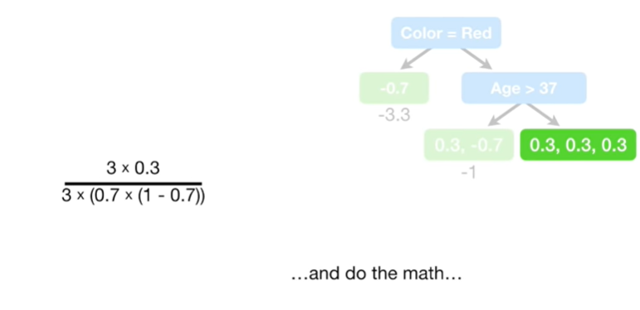

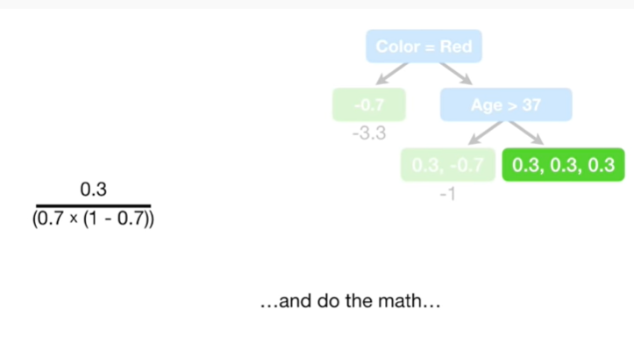

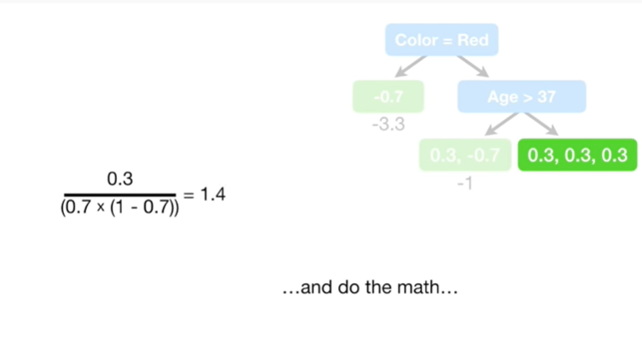

and do the math

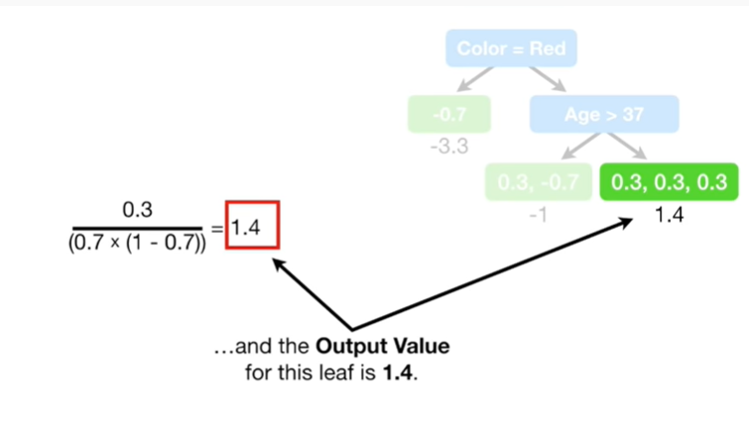

and the output value for this leaf is 1.4.

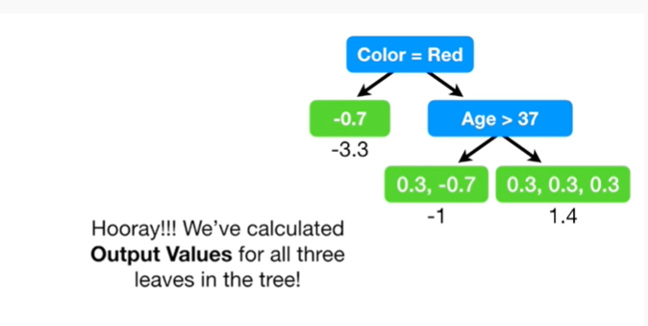

Hooray !!!

We've calculated the output values for all three leaves in the tree !

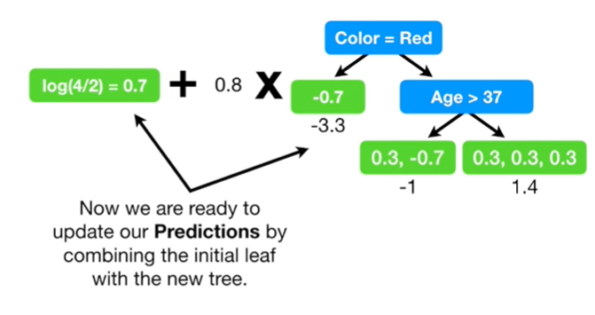

Now we are ready to update our predictions by combining the initial leaf with the new tree.

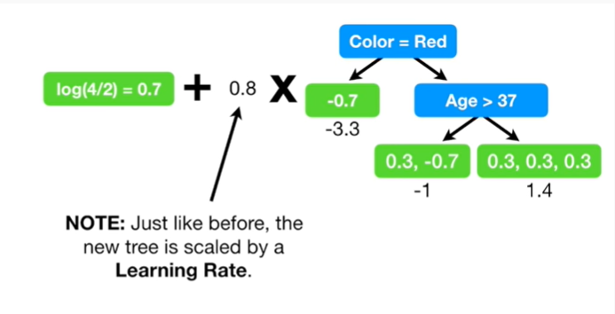

Note : just like before the new tree is scaled by a learning rate.

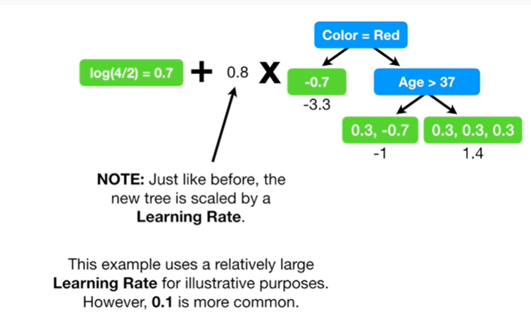

This example uses a relatively large learning rate for illustrative purposes.

However, 0.1 is more common.

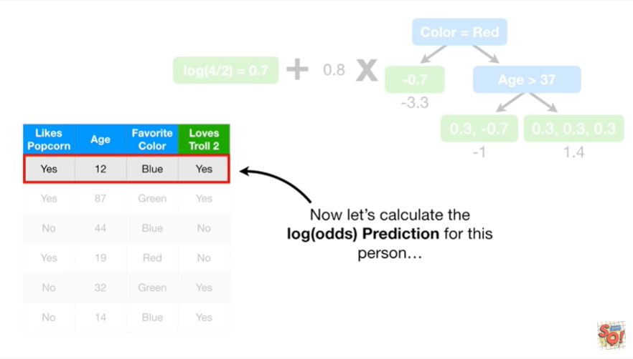

Now let's calculate the log of the odds prediction for this person.

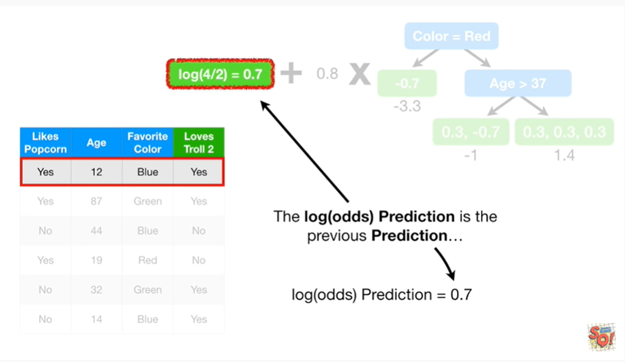

The log of the odds prediction is the previous prediction 0.7

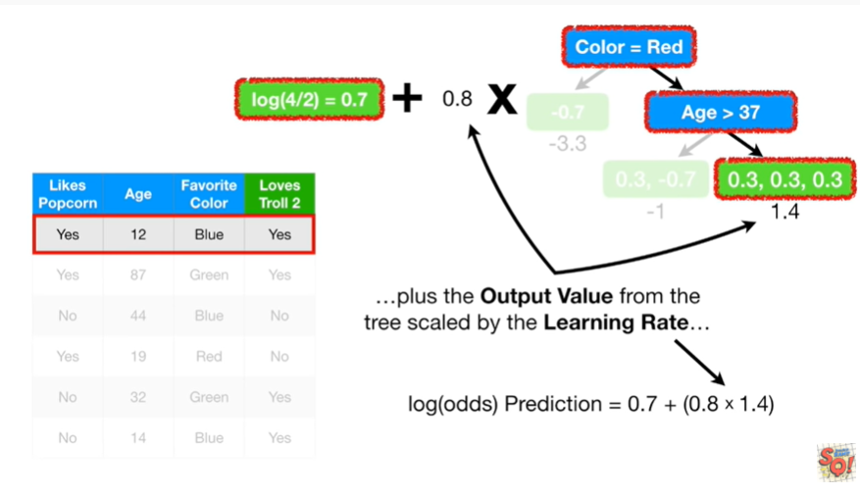

plus the output value from the tree scaled by the learning rate 0.8 times 1.4

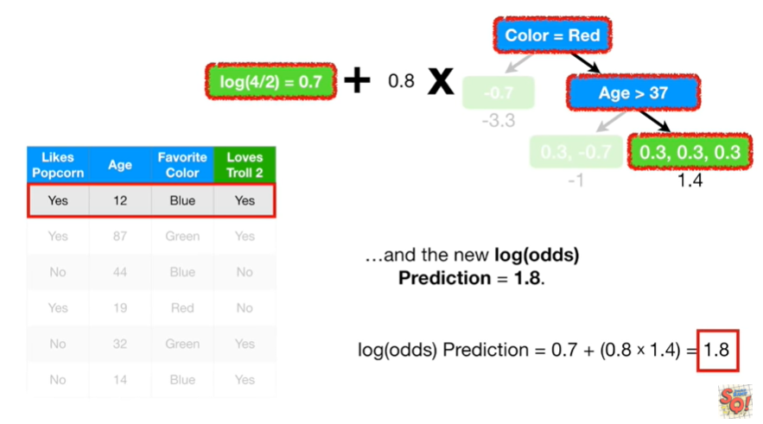

and the new log of the odds prediction equals 1.8.

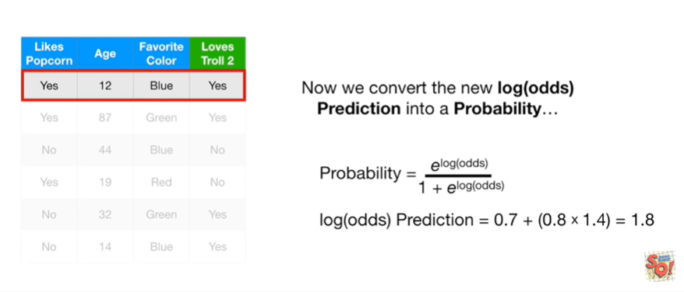

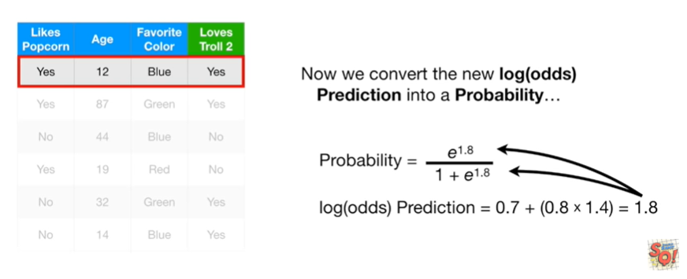

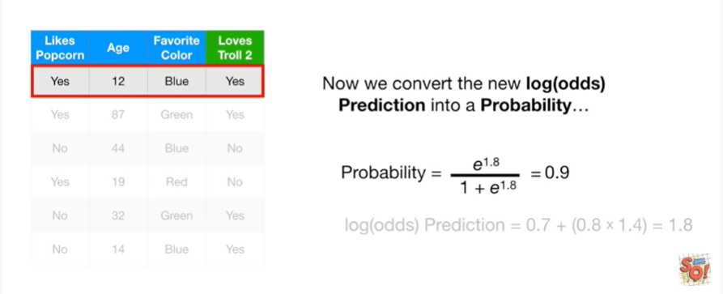

Now we can convert the new log-odds prediction into a probability

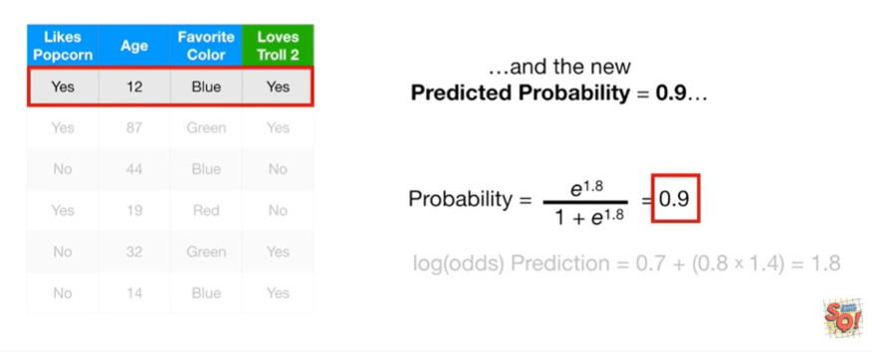

and the new predicted probability equals 0.9

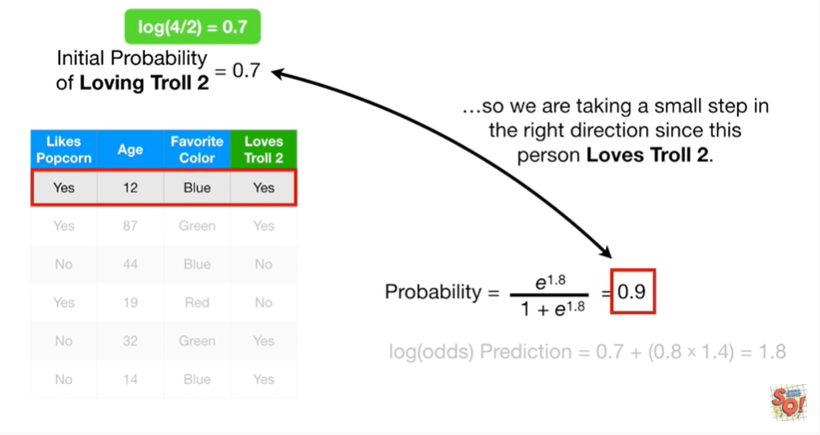

So we are taking a small step in the right direction since this person loves troll 2.

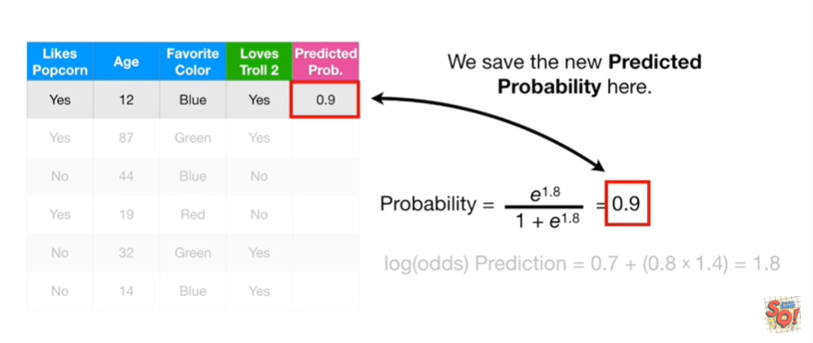

We save the new predicted probability here.

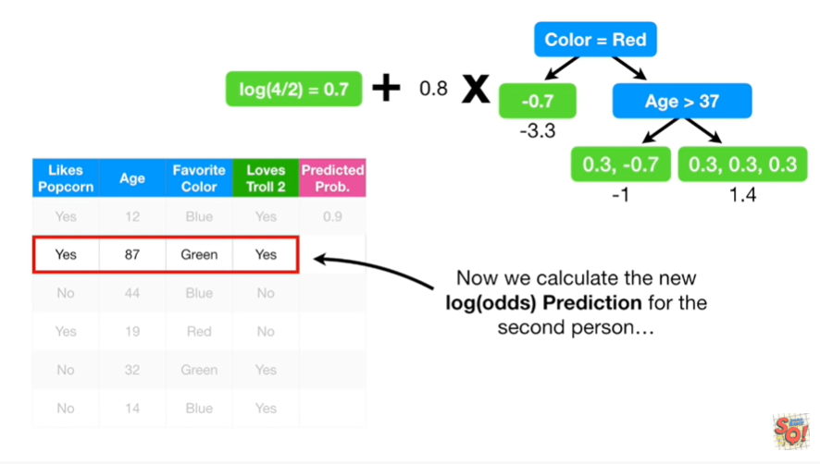

Now we calculate the new log of the odds prediction for the second person.

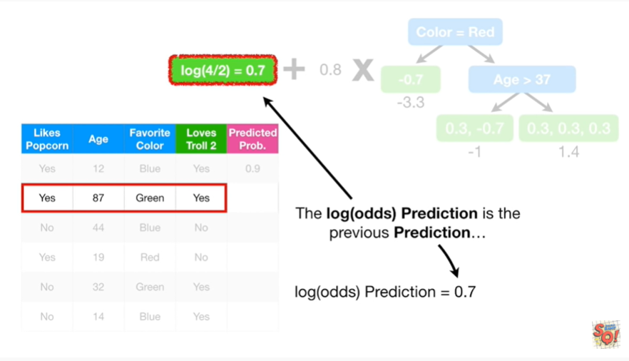

The log of the odds prediction is the previous prediction 0.7

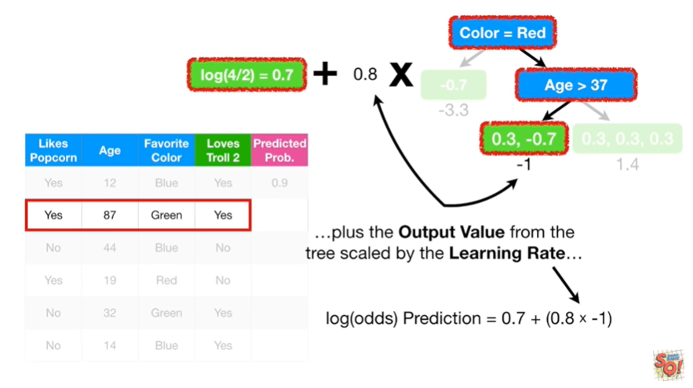

plus the output value from the tree scaled by the learning rate 0.8 times negative one

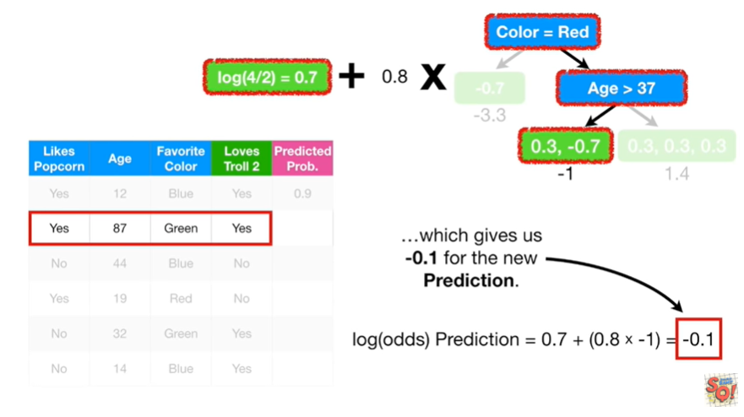

which gives us negative 0.1 for the new prediction.

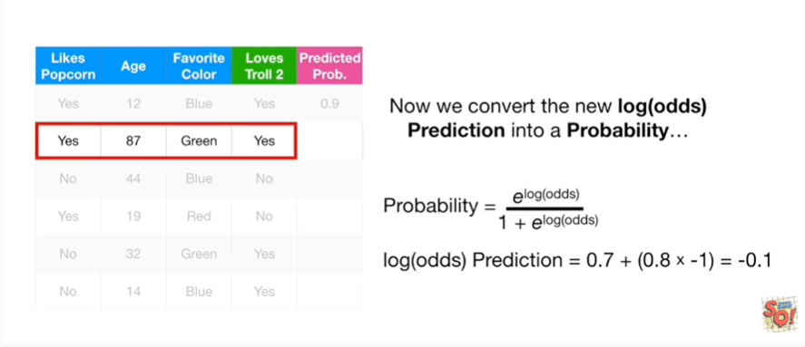

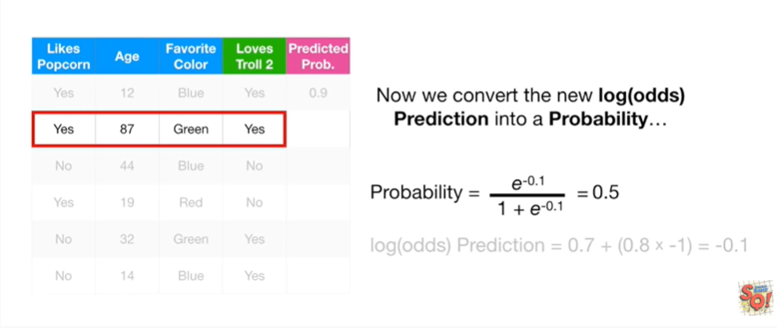

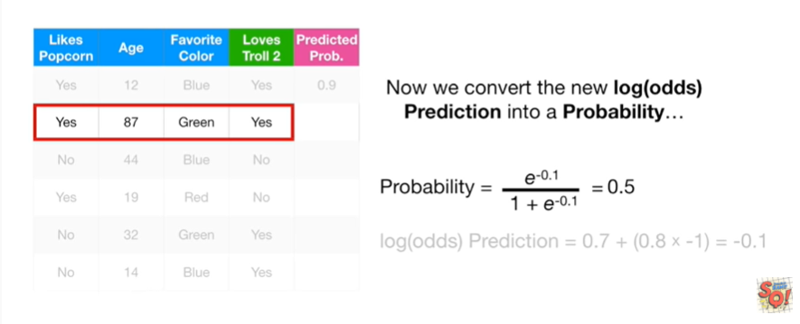

We can convert the log of the odds prediction into a probability

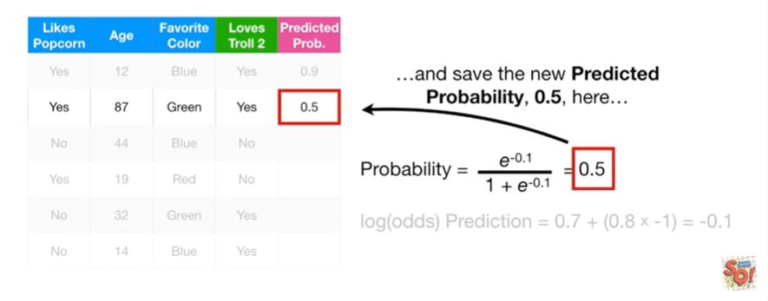

and save the new predicted probability 0.5 here.

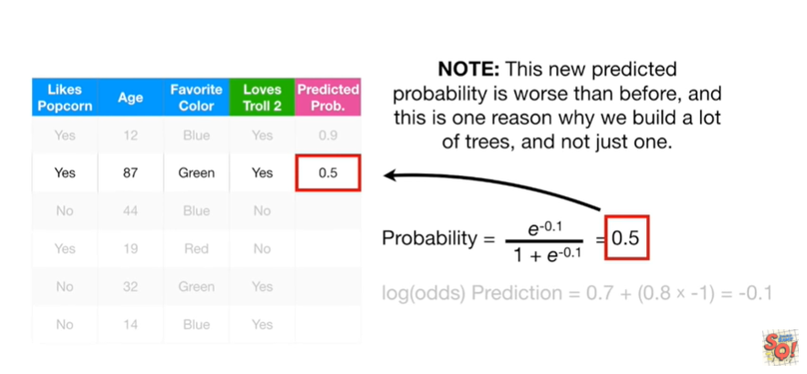

Note this new predicted probability is worse than before and this is one reason why we built a lot of trees, and not just one.

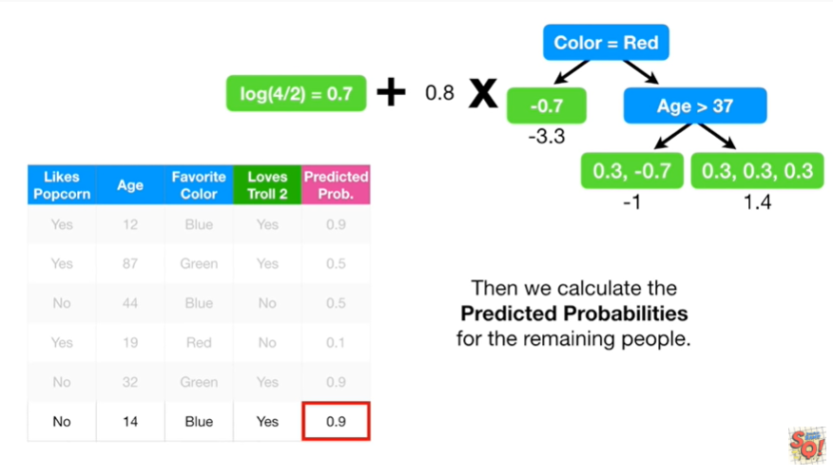

Then we calculate the predicted probabilities for the remaining people.

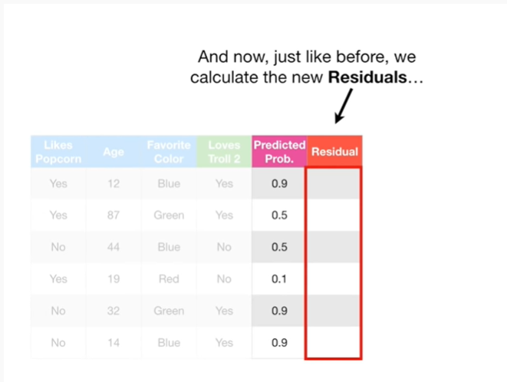

And now just like before we calculate the new residuals

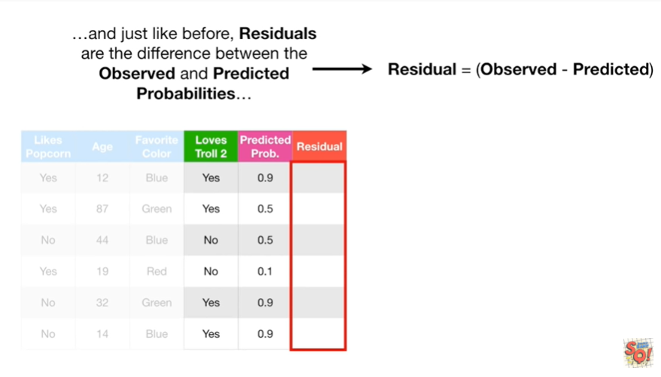

and just like before residuals are the difference between the observed and predicted probabilities

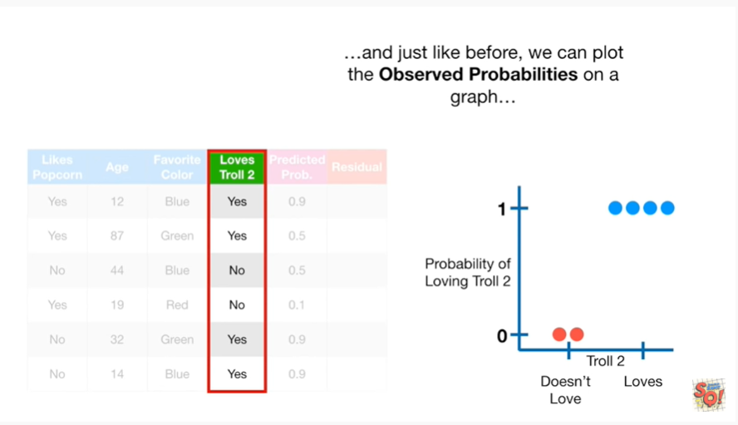

and just like before we can plot the observed probabilities on a graph

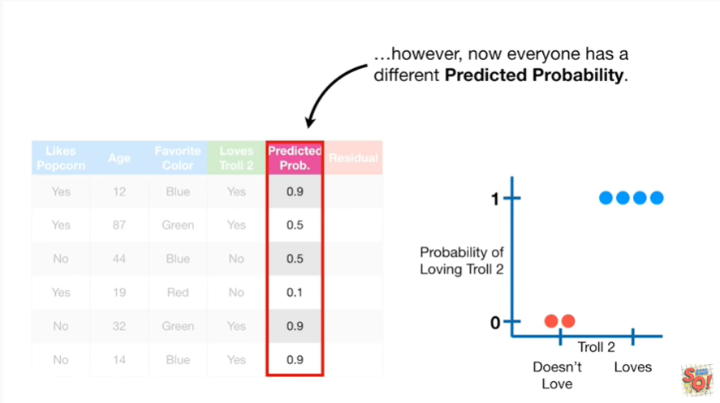

however now everyone has a different predicted probability.

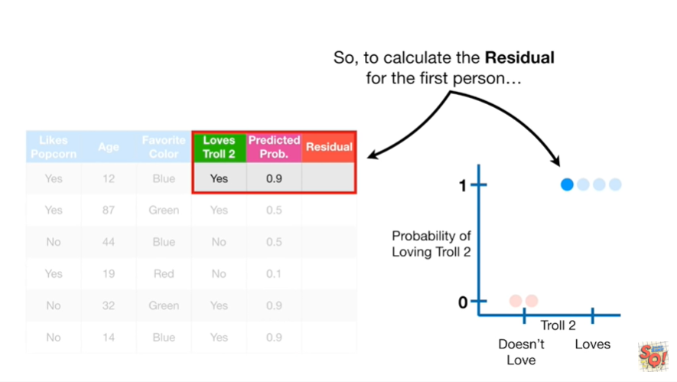

So to calculate the residual for the first person

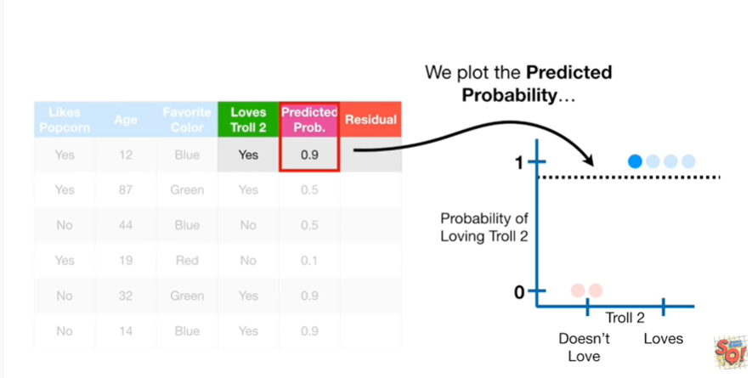

we plot the predicted probability

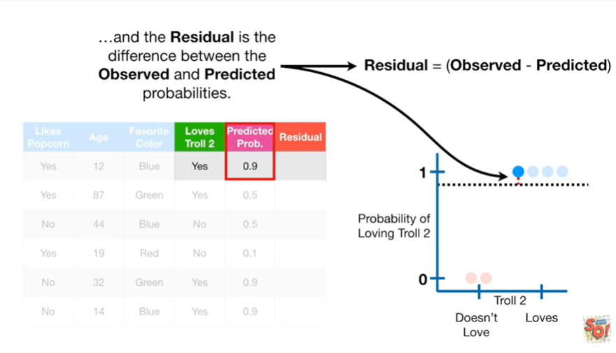

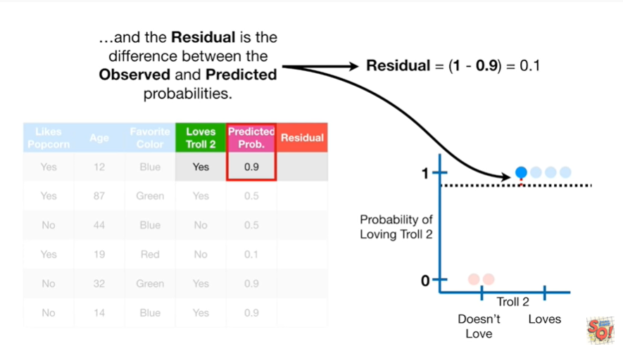

and the residual is the difference between the observed and predicted probabilities

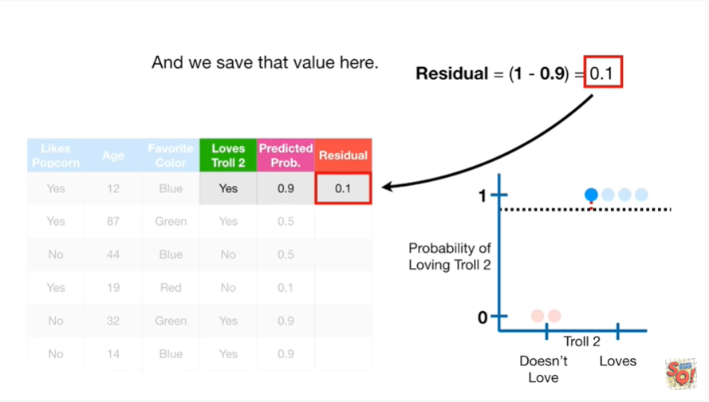

and we save that value here.

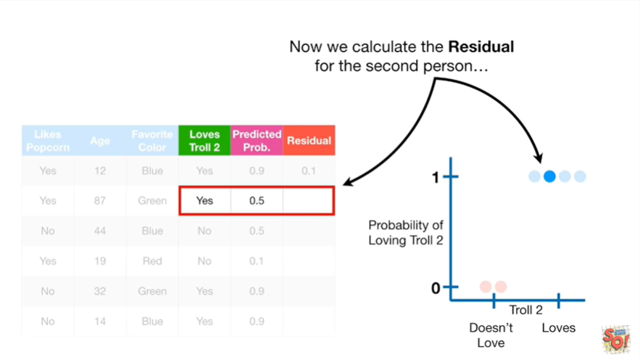

Now we calculate the residual for the second person.

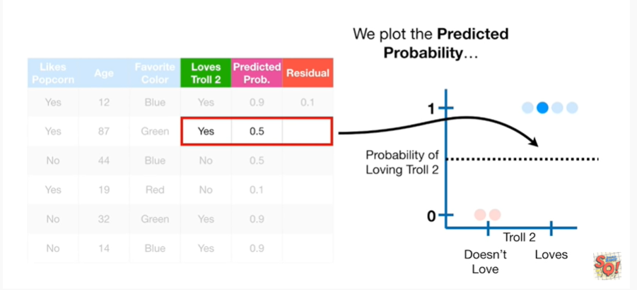

We plot the predicted probability

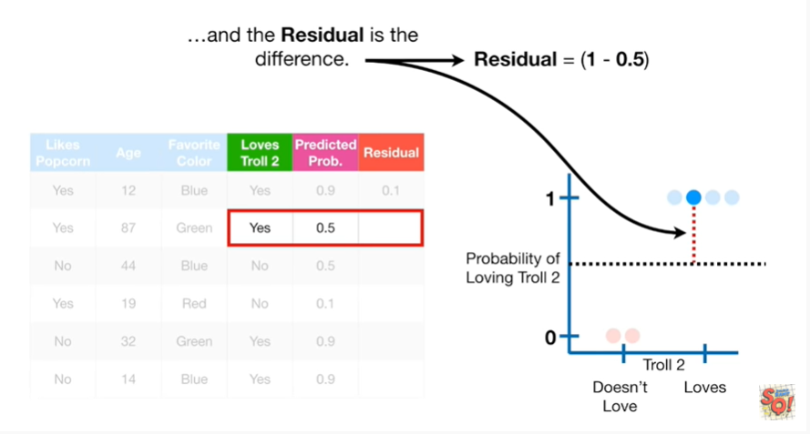

and the residual is the difference.

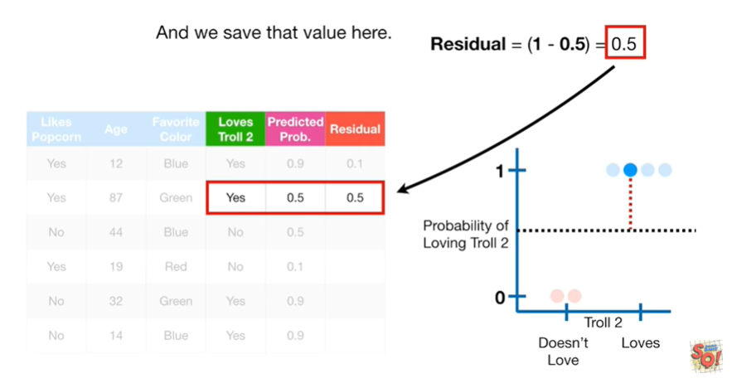

And we save that value here.

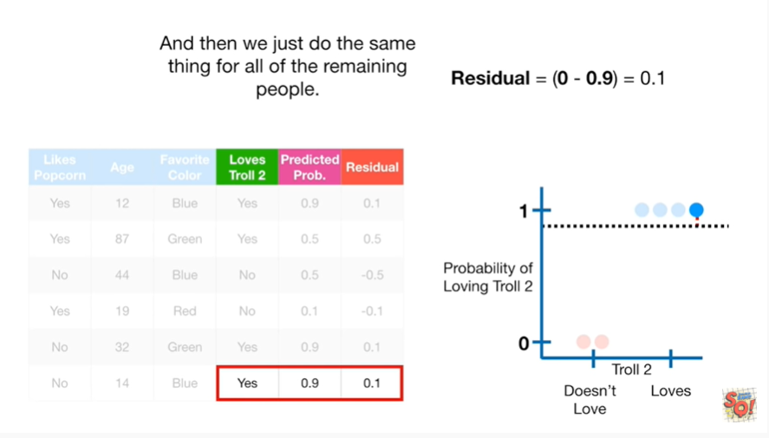

We just do the same thing for all the remaining people.



BAM !!!

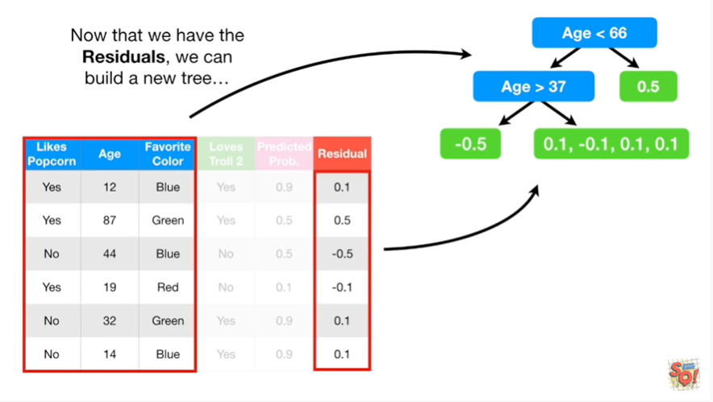

Now that we have the residuals we can build a new tree

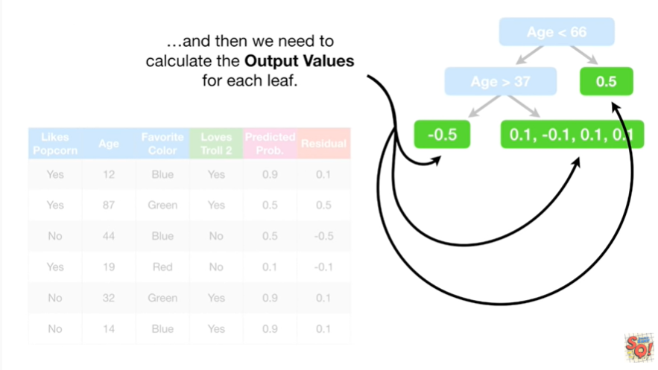

and then we need to calculate the output values for each leaf.

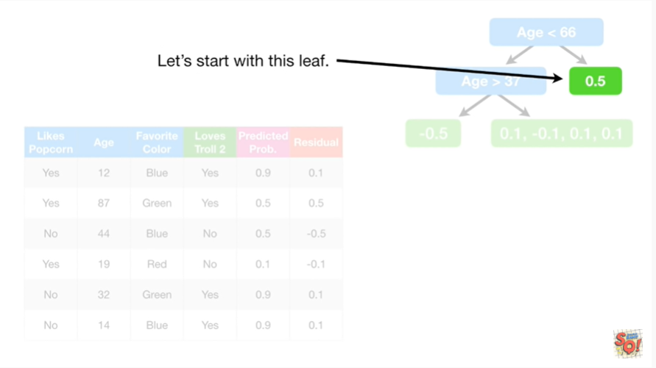

Let's start with this leaf.

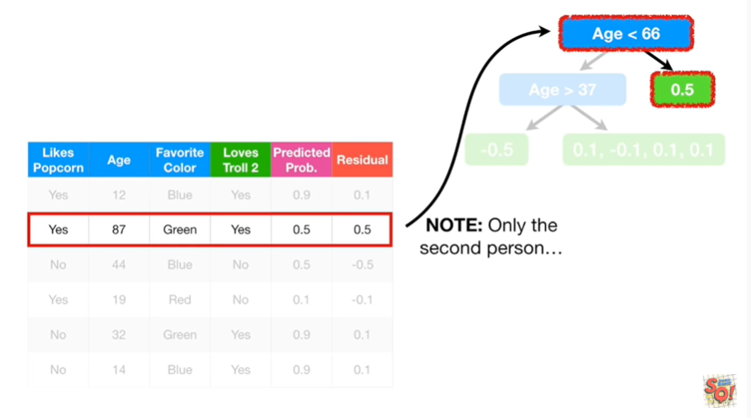

Note : only the second person

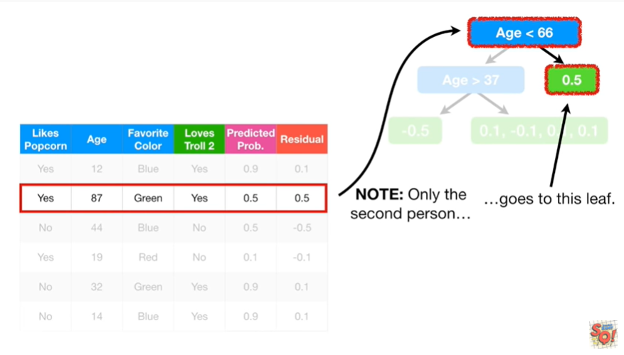

goes to this leaf.

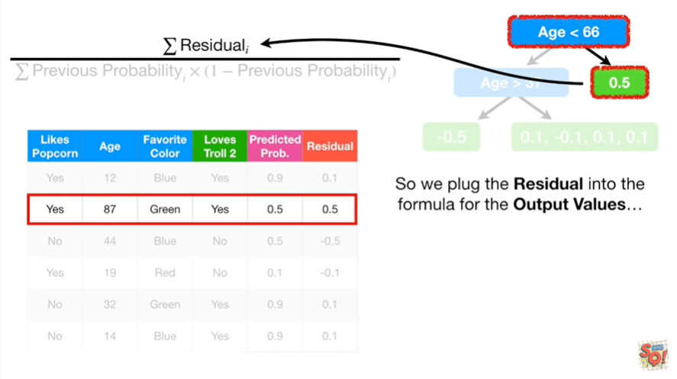

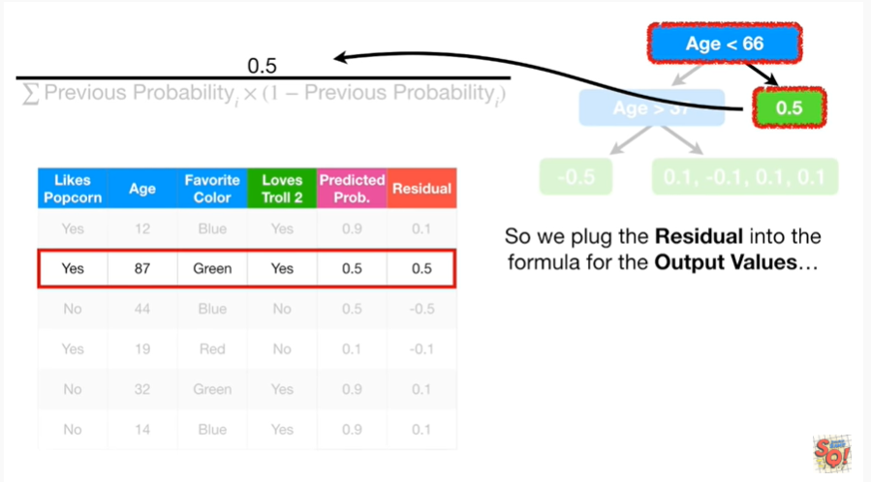

So we plug in the residual into the formula for the output values

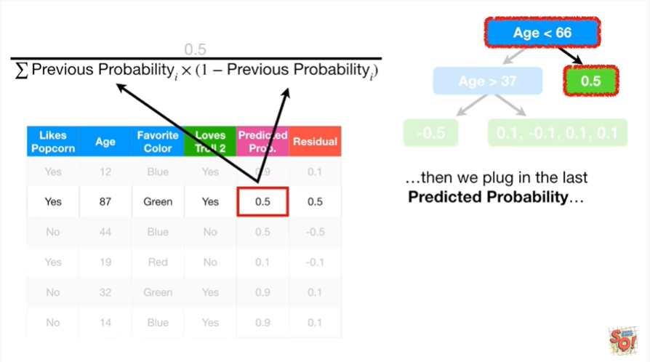

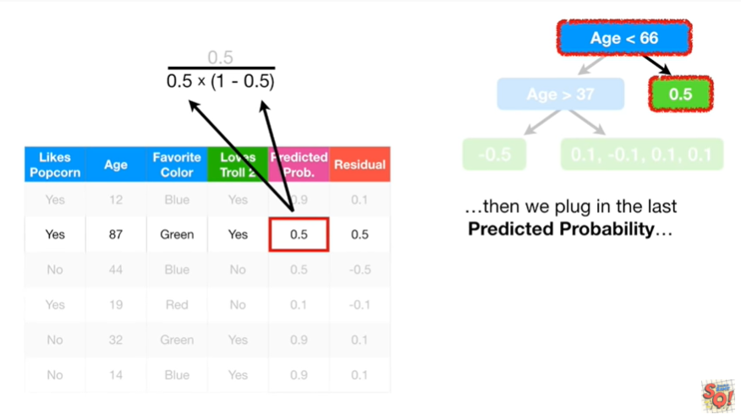

then we plug in the last predicted probability

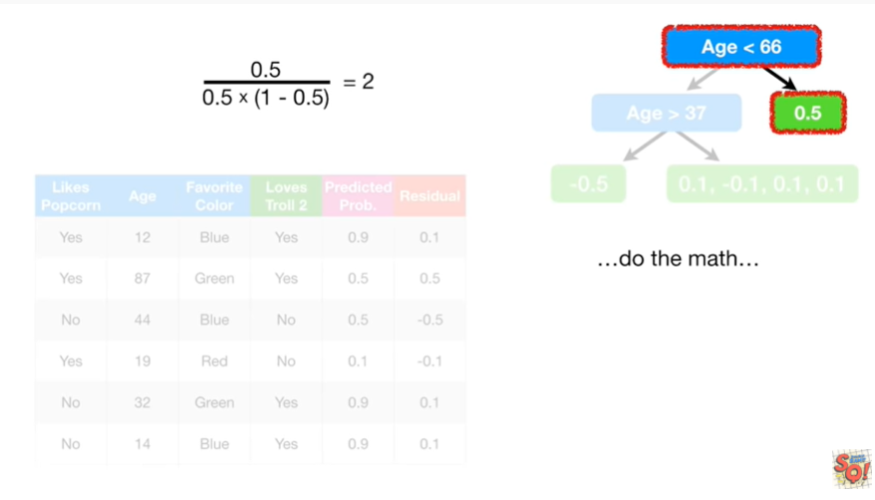

do the math

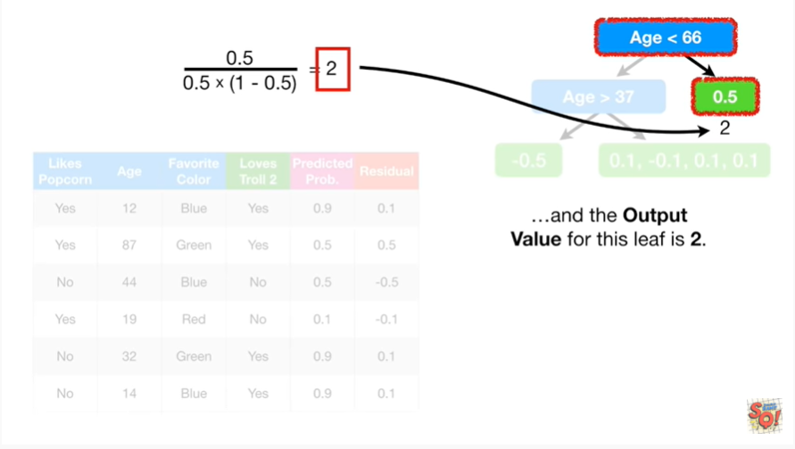

and the output value for this leaf is 2.

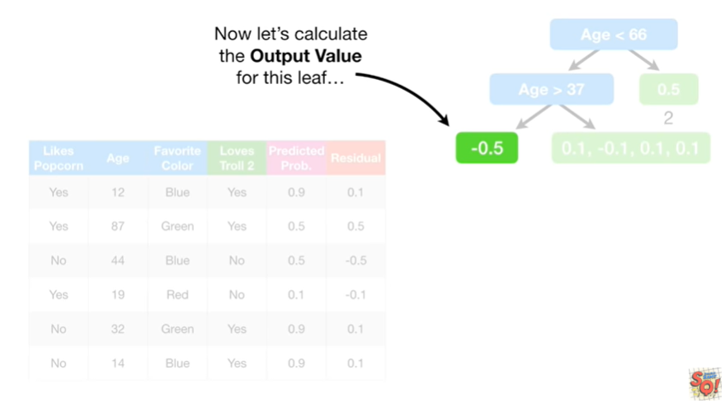

Now let's calculate the output value for this leaf.

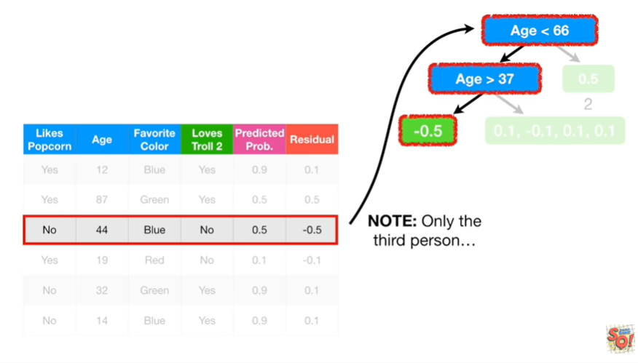

Note : only the third person

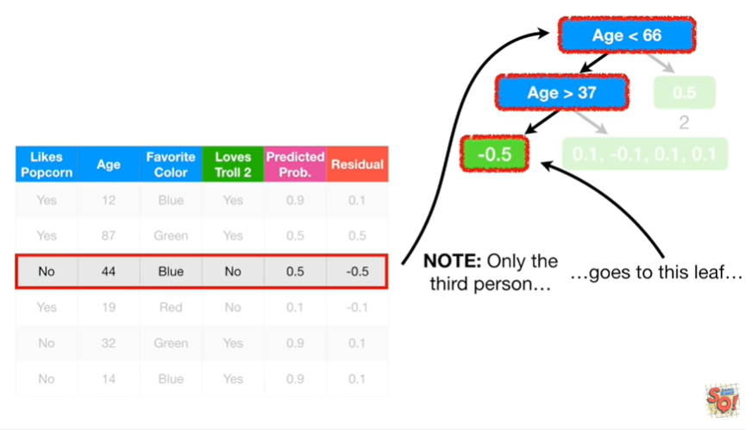

goes to this leaf.

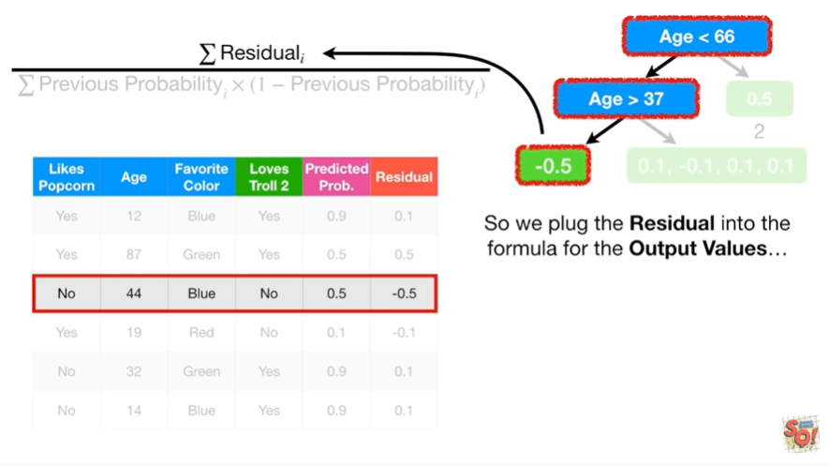

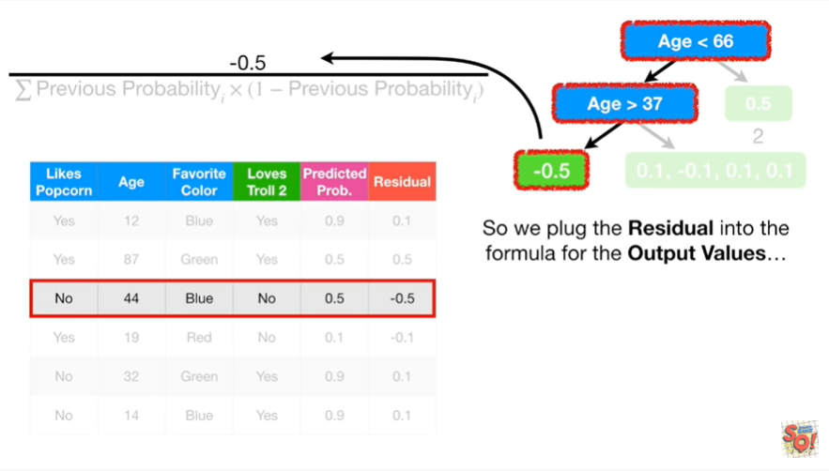

So we plug the residual into the formula for the output values

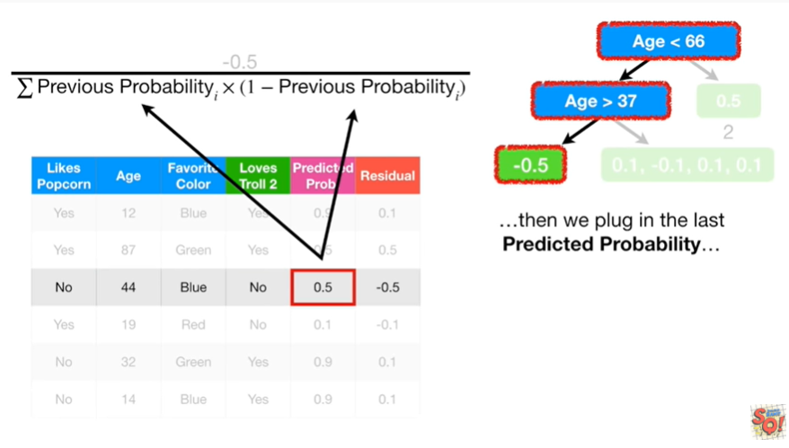

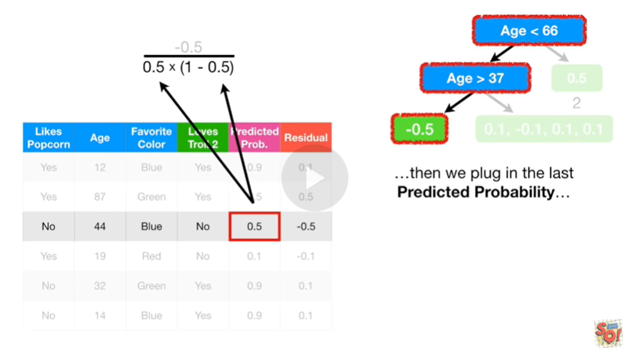

then we plug in the last predicted probability

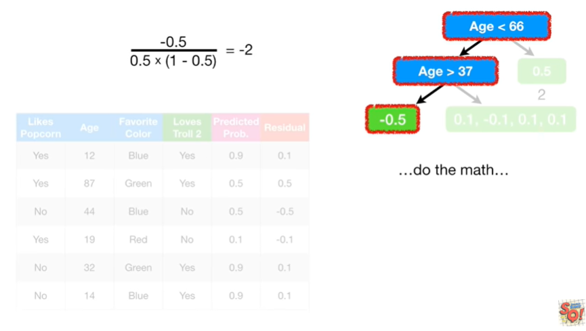

do the math

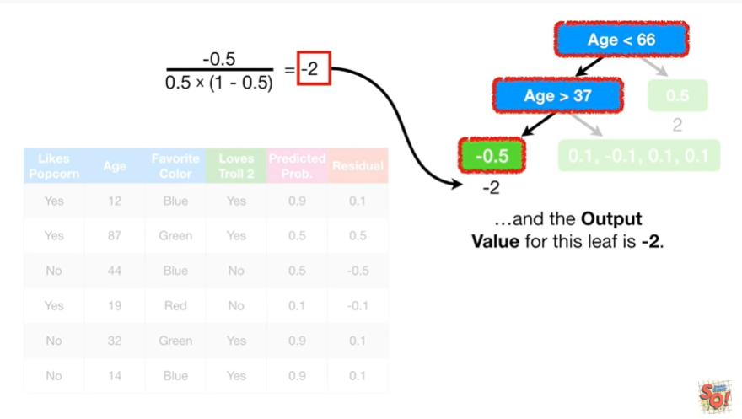

and the output value for this leaf is negative 2.

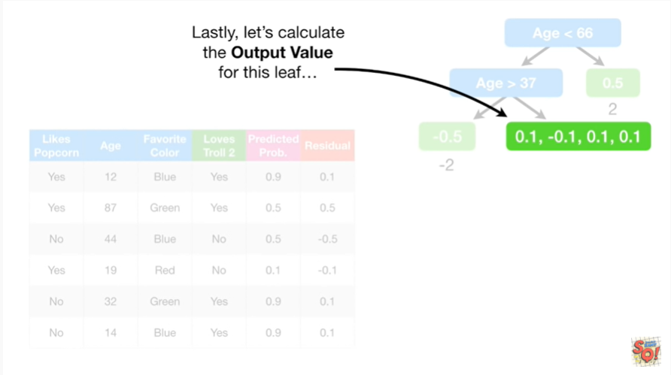

Lastly, let's calculate the output value for this leaf.

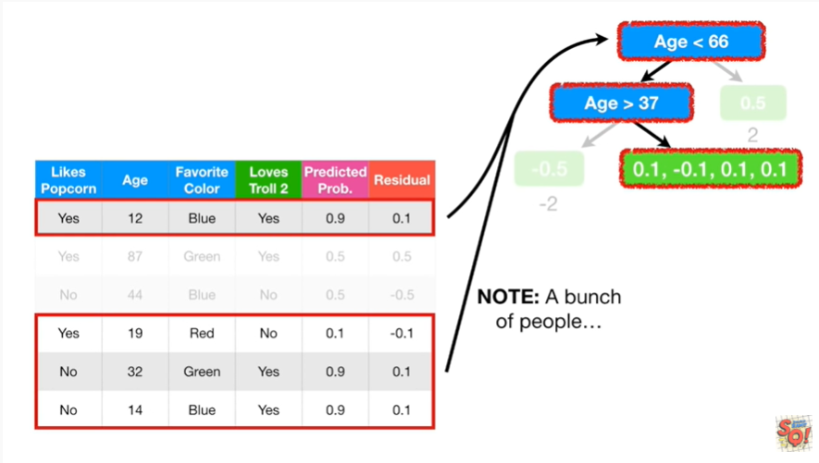

Note : a bunch of people

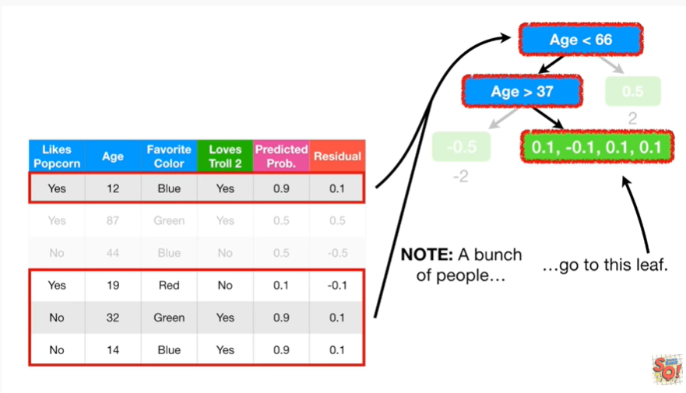

go to this leaf.

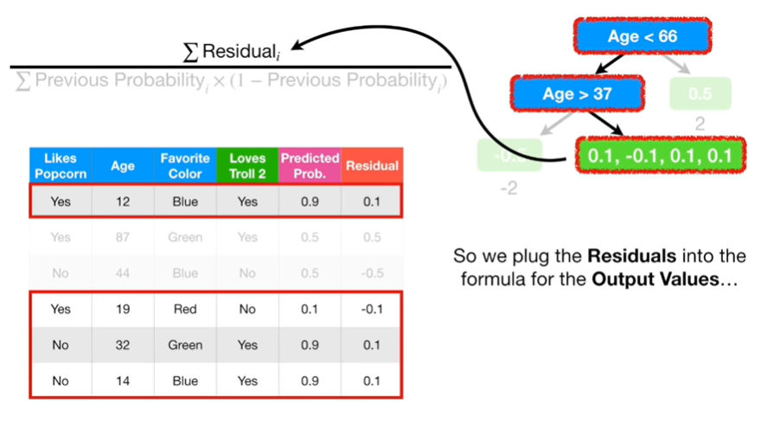

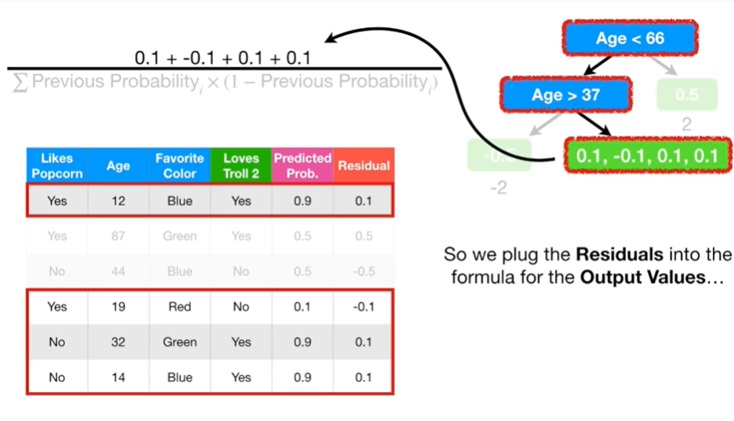

So we plugged the residuals into the formula for the output values

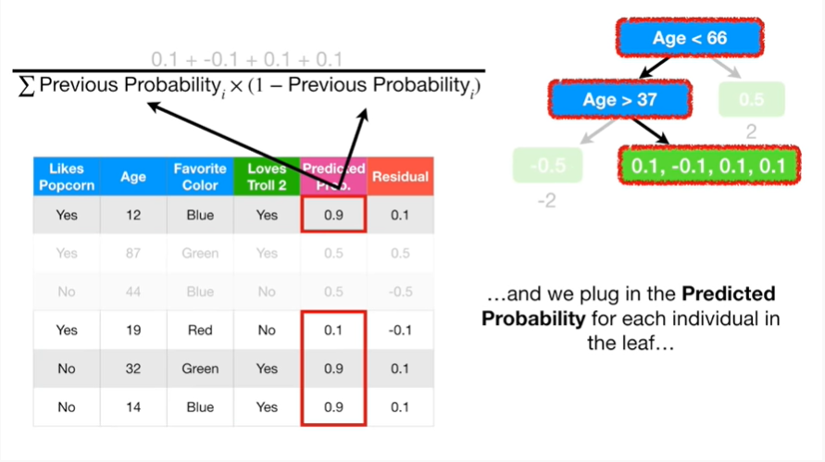

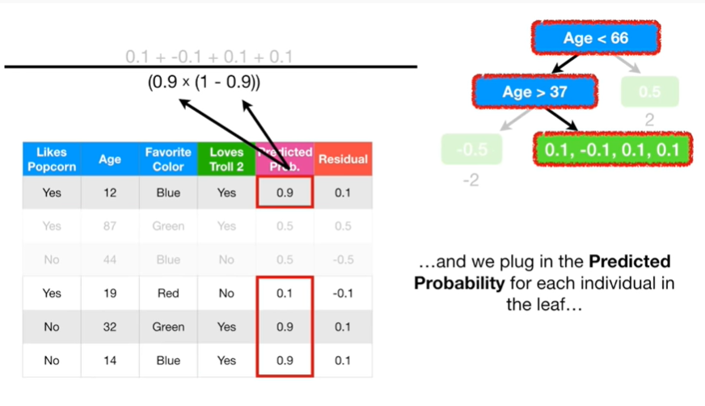

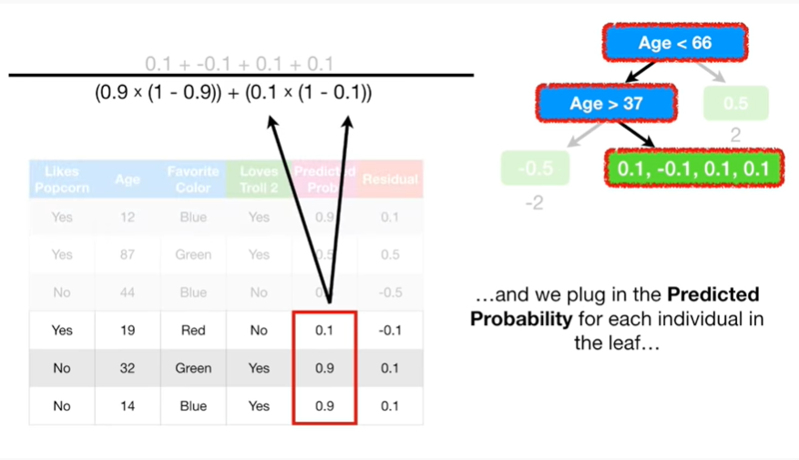

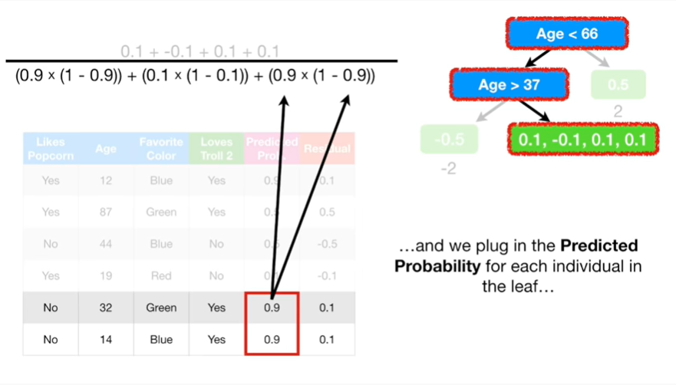

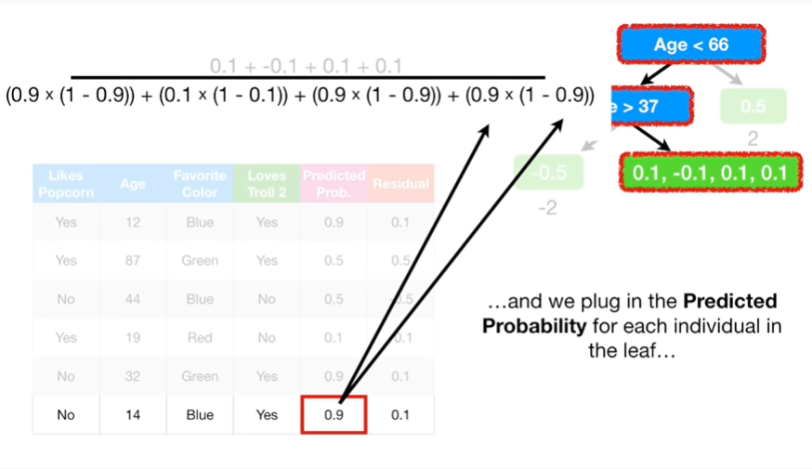

and we plug in the predicted probability for each individual in the leaf

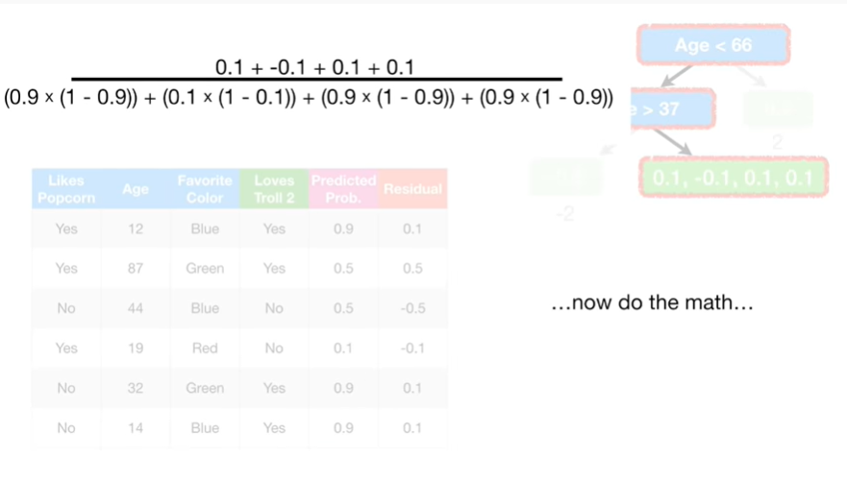

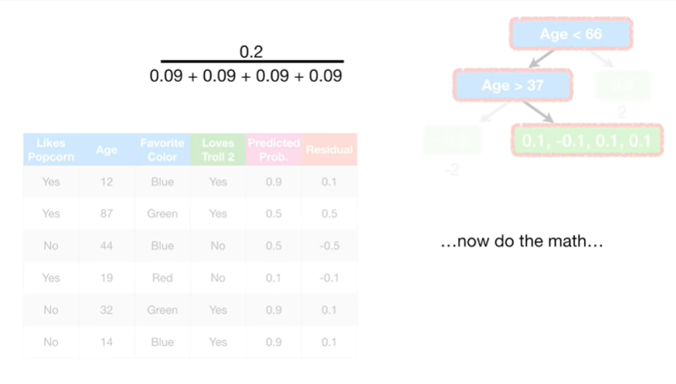

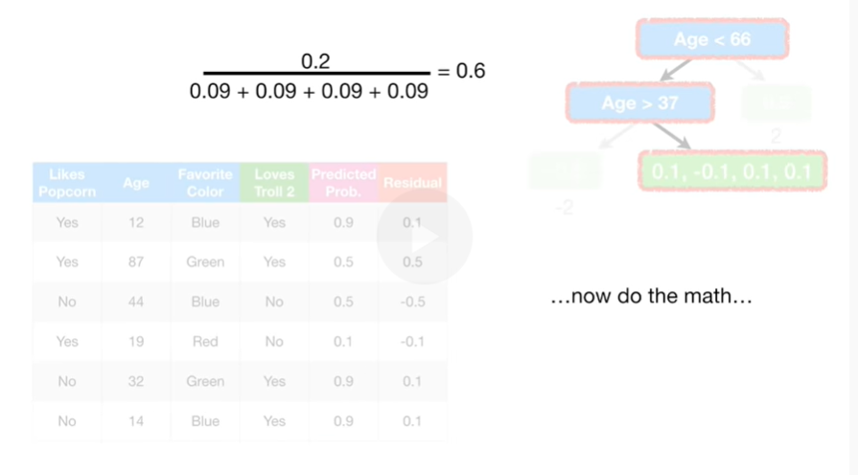

now do the math

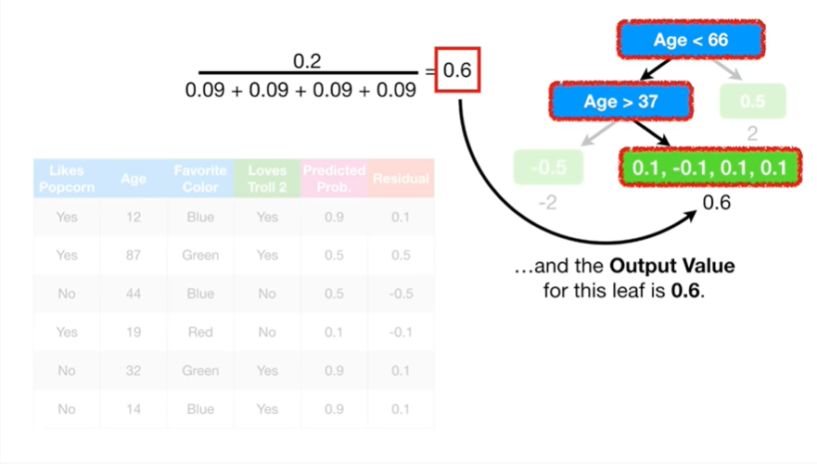

and the output value for this leaf is 0.6.

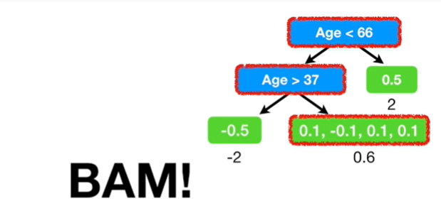

BAM !

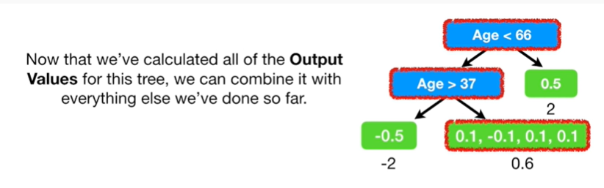

Now that we've calculated all of the output values for this tree, we can combine it with everything else we've done so far.

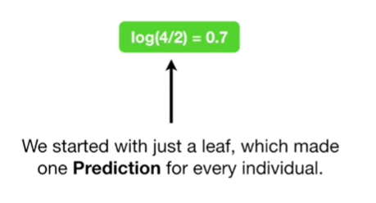

We started with just a leaf which made one prediction for every individual.

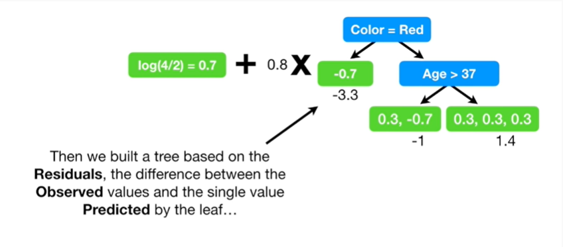

Then we built a tree based on the residuals, the difference between the observed values and the single value predicted by the leaf

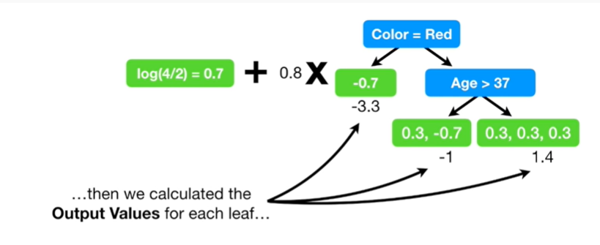

then we calculated the output values for each leaf

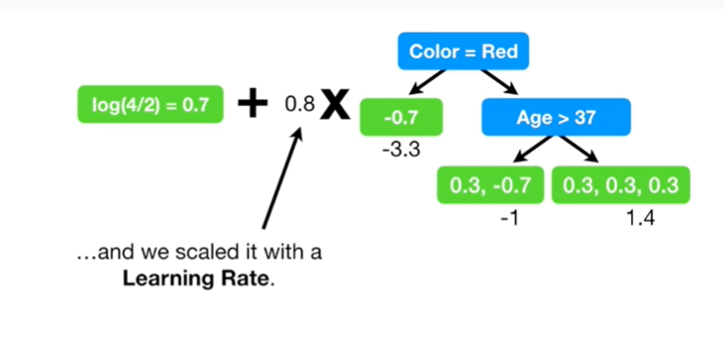

and we scaled it with a learning rate.

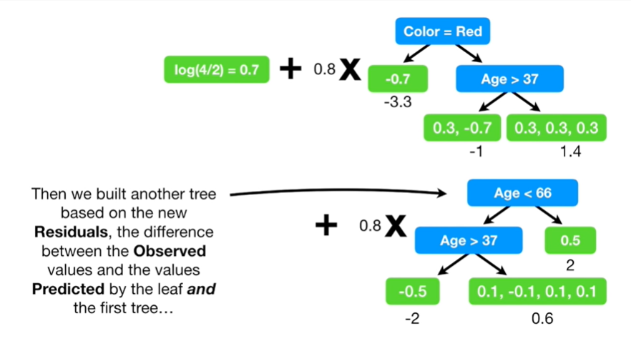

Then we built another tree based on the new residuals, the difference between the observed values and the values predicted by the leaf and the first tree

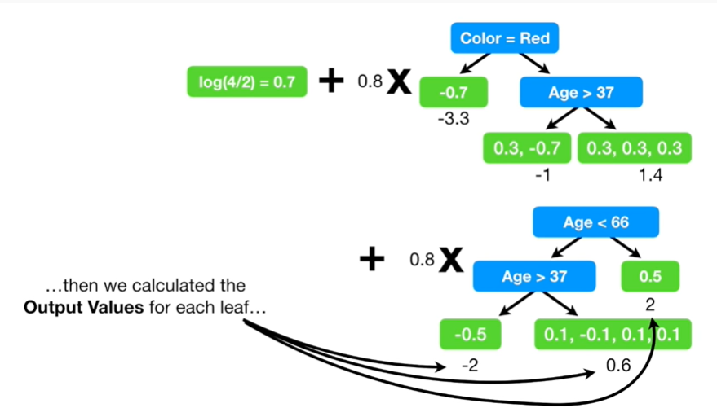

then we calculated the output values for each leaf

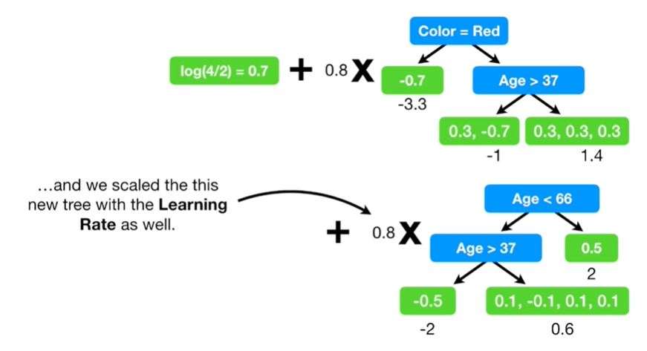

and we scale this new tree with the learning rate as well.

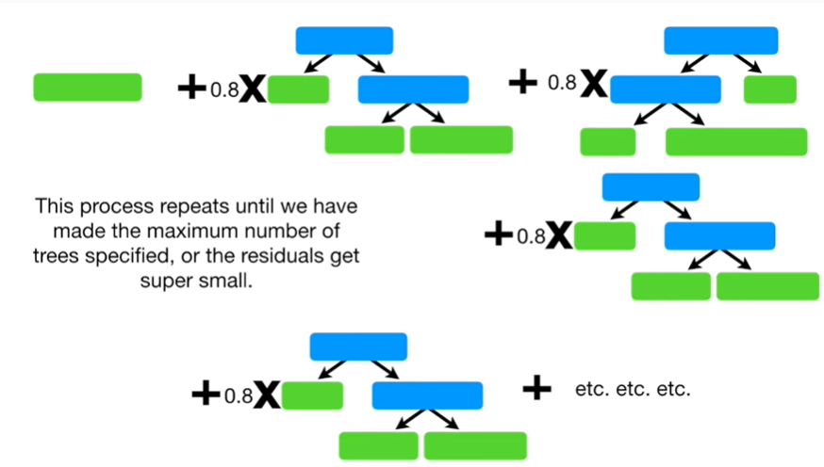

This process repeats until we have made the maximum number of trees specified, or the residuals get super small.



Double BAM !!!

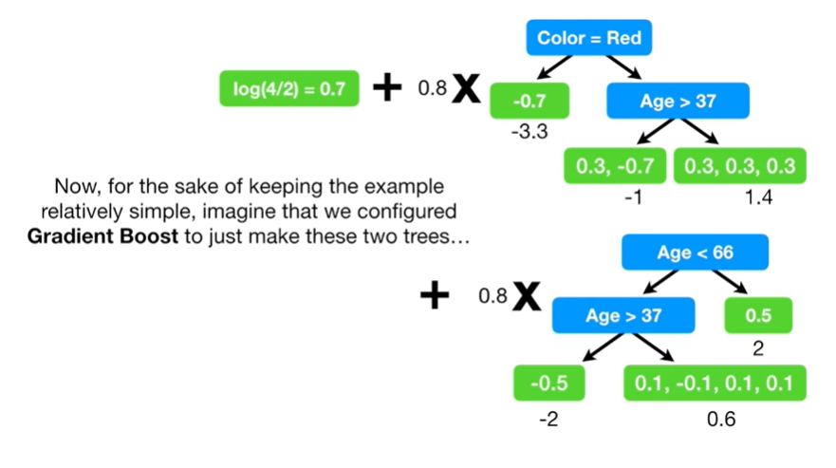

Now, for the sake of keeping the example relatively simple, imagine that we configured gradient boost to just make these two trees

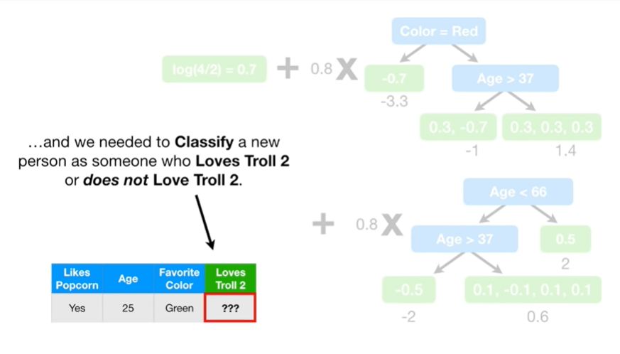

and we needed to classify a new person as someone who loves to roll 2 or does not love troll 2.

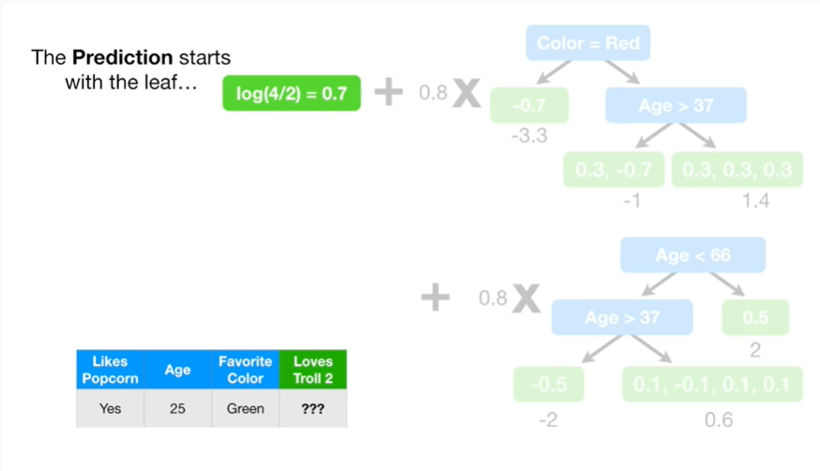

The prediction starts with the leaf

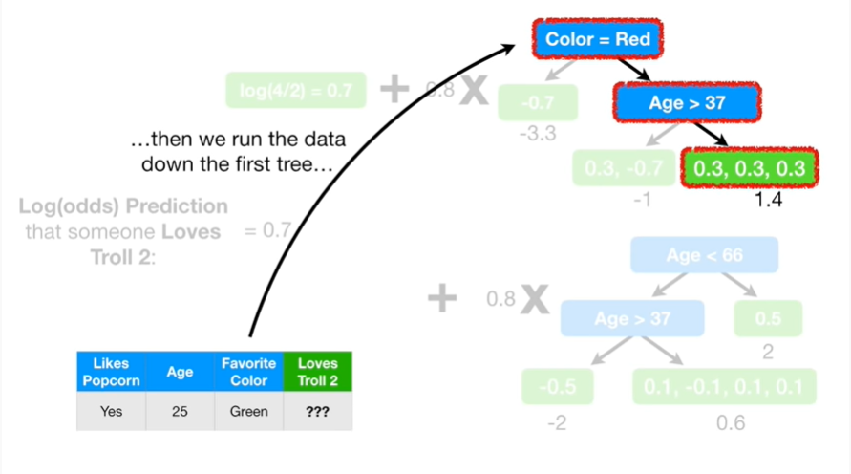

then we run the data down the first tree

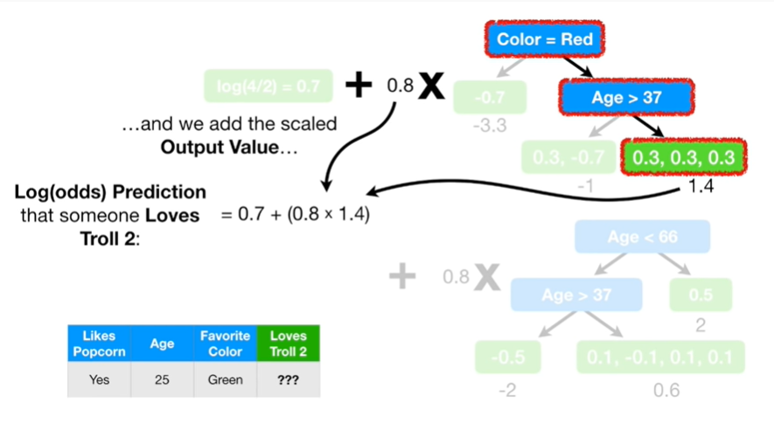

and we add the scaled output value

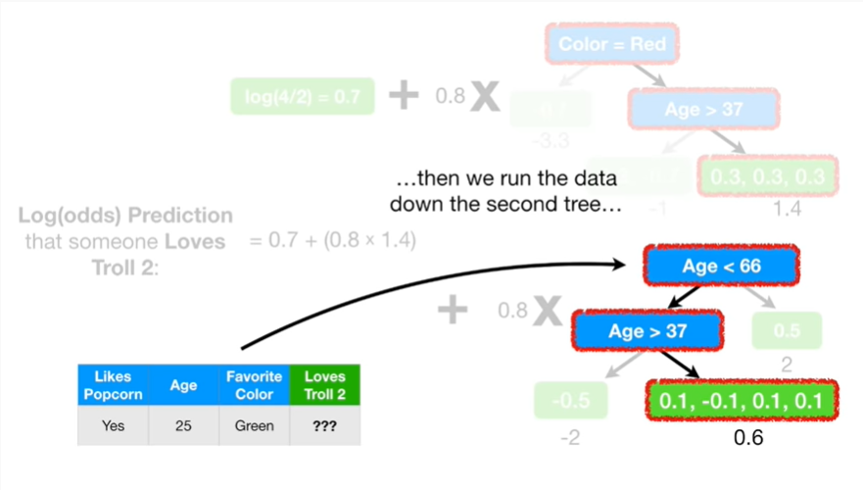

then we run the data down the second tree

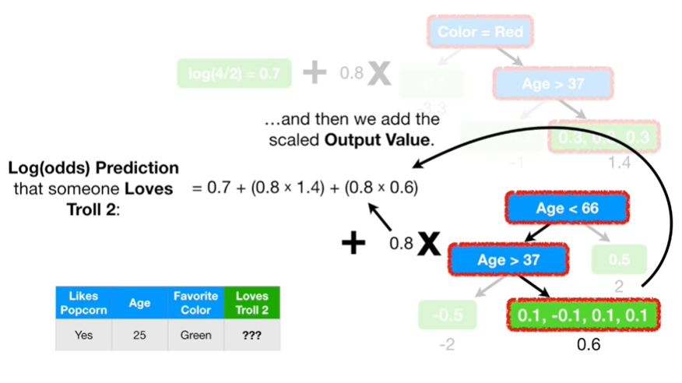

and then we add the scaled output value.

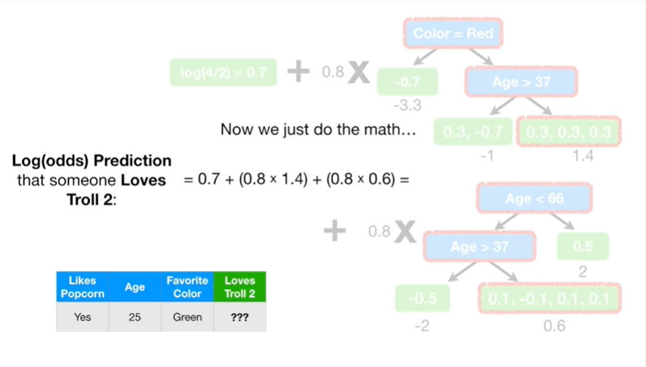

Now we just do the math

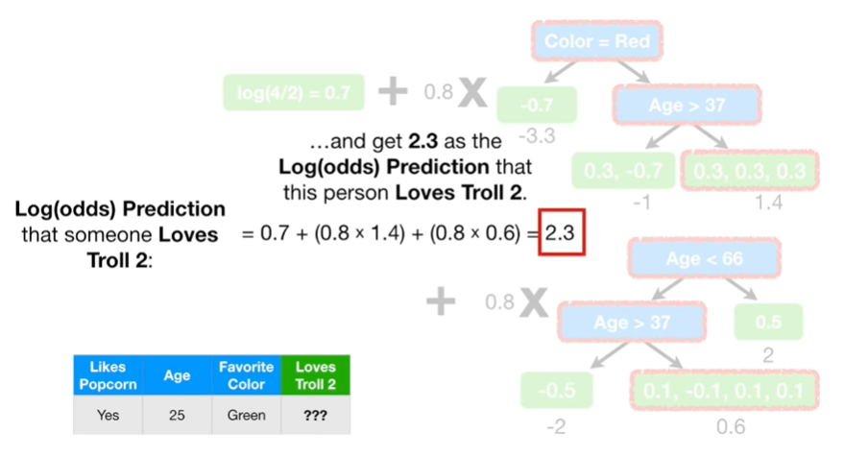

and get 2.3 as the log of the odds prediction that this person loves troll 2.

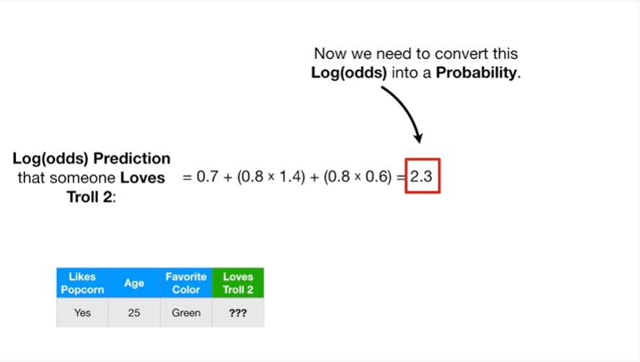

Now we need to convert this log of the odds into a probability.

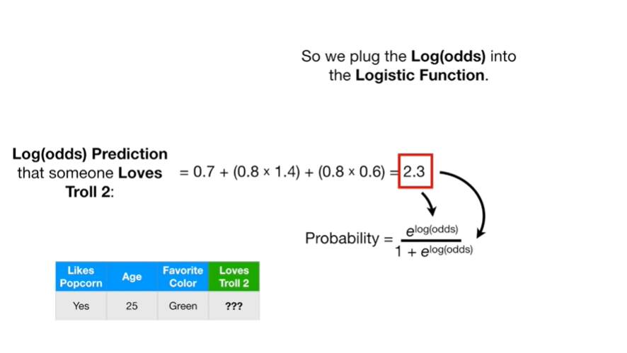

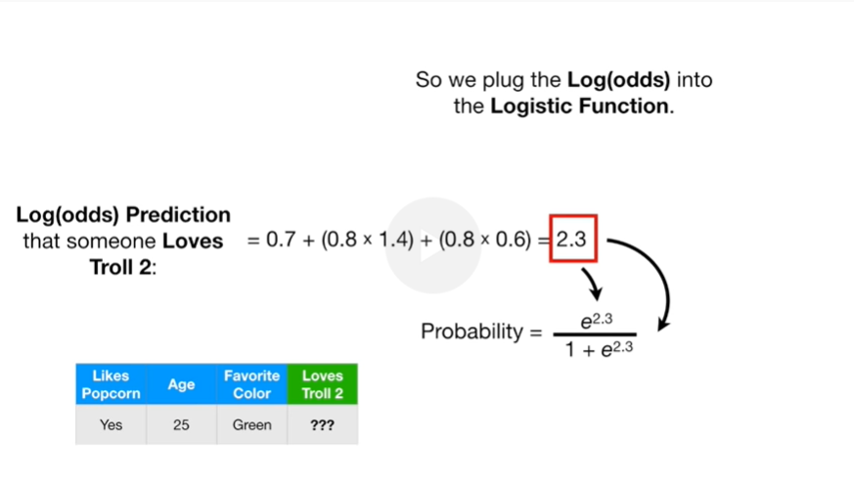

So we plug the log of the odds into the logistic function

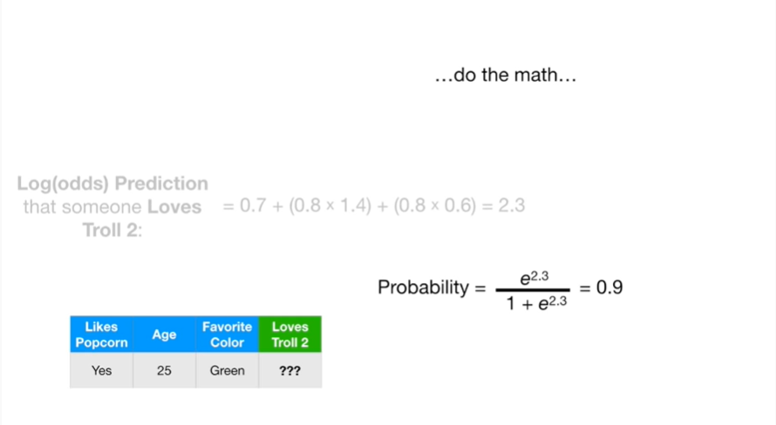

do the math

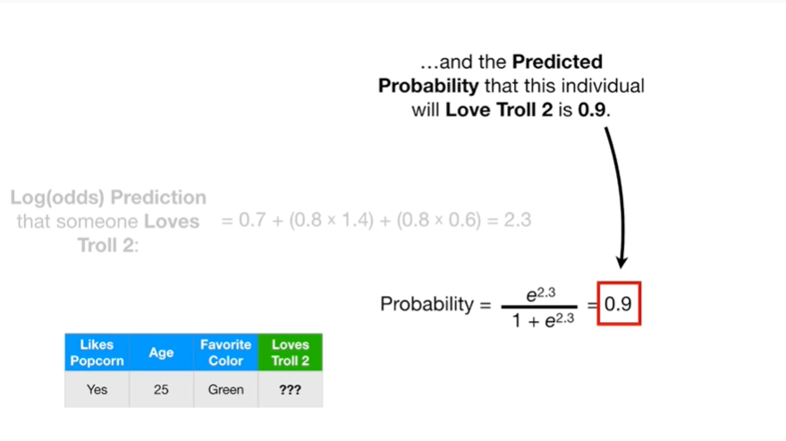

and the predicted probability that this individual will love troll 2 is 0.9.

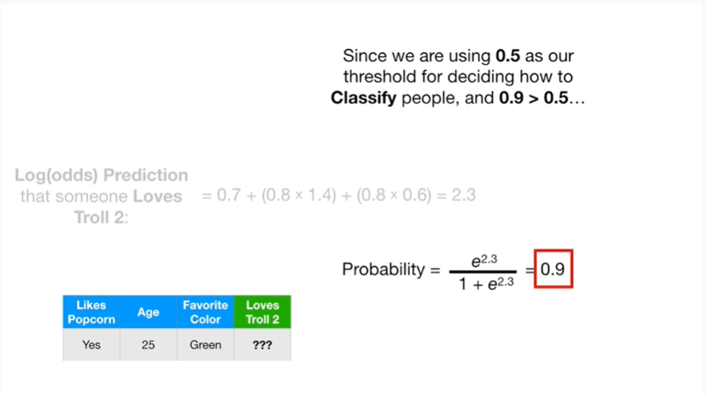

Since we are using 0.5 as our threshold for deciding how to classify people, and 0.9 is greater than 0.5

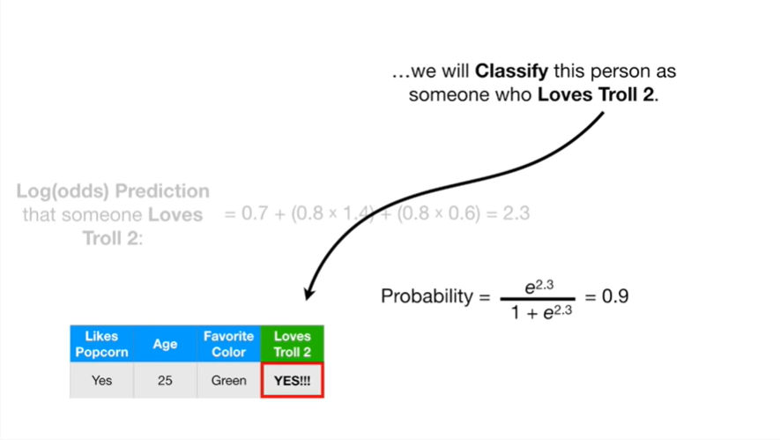

we will classify this person as someone who loves troll 2.



Triple bam !!!

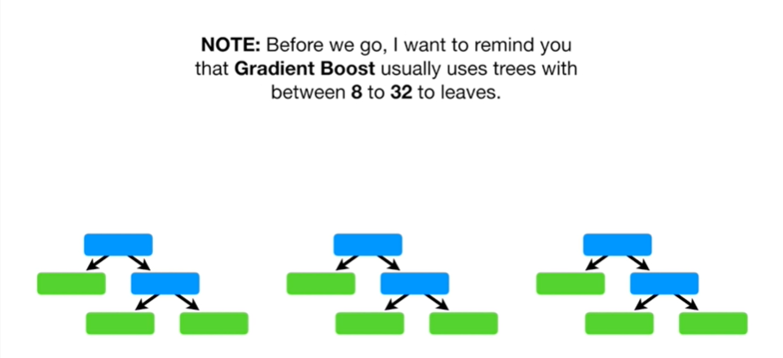

Note : before we go, I want to remind you that gradient boost usually uses trees with between 8 and 32 leaves.

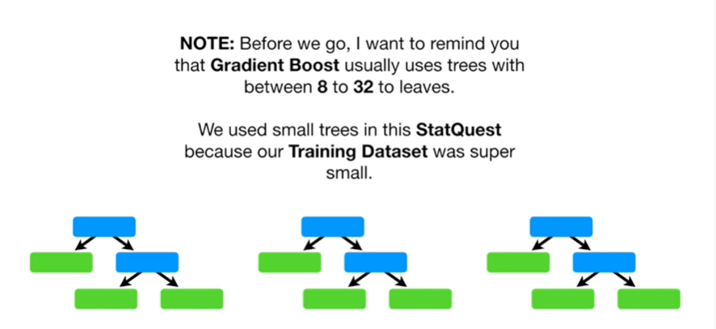

We use small trees in this stat quest because our training data set was super small.



Also be sure to watch part four of this exciting series on gradient boost next time we'll dive deep into the math of how gradient boost is used for classification !

We'll derive the equation used to update the leaves and that will make you feel totally awesome.